# Azure DevOps Site Reliability

# 

1. **Introduction**

Let's say that you have an application that has been posted on a set of virtual machines in a single. So it’s very important thing when it comes to site reliability. It's almost near to impossible to achieve 100 percent uptime for your application infrastructure.

Now, when it comes to improving site reliability, when it comes to improving high availability for applications, there are other services that we also have and we're going to go ahead and touch upon.

* Azure Load Balancer
* Azure Virtual Machine Scale Sets
* Azure Traffic Manager

1. **Azure Load Balancer:**

Let’s you have a set of virtual machines in a Azure and let's say you have an application being hosted on these virtual machines.

Now, when users go ahead and access the application, you want to ensure that the user requests are directed equally across these virtual machines. This ensures that you have a load balance of requests

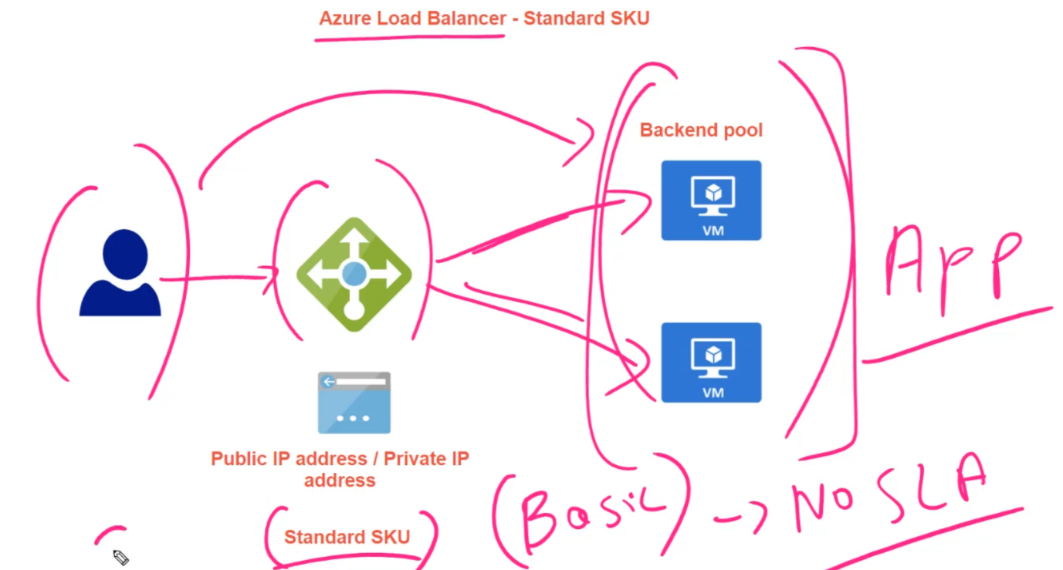

So until the users directly hitting the application on the virtual machines, the request will go through the as your load balancer and then as your load balancer can go ahead and redirect the request onto the backend virtual machines. That's the entire purpose of the OCR load balancer.

Two Pricing Model Available: Basic SKU & Standard SKU

1. **In basics SKU** - you don't get any SLA, you don't get any service level agreement.
2. **In the standard SKU** - you do get SLA, so production-based environment you should prefer Standard SKU

**Step 1:** Create two virtual machines and deploy your application on VMs.

**Step 2:** Before setting up load balancer first got to your VM and disable the Public IP address – And this is because we are not allowing user to access the website using public IP address, instead only allow them to hitting the Internet information services on these virtual machines via the public IP address of the load balancer.

**Go to networking -> Network Interface -> IP Configuration -> IP Config -> Disassociate the Public IP**

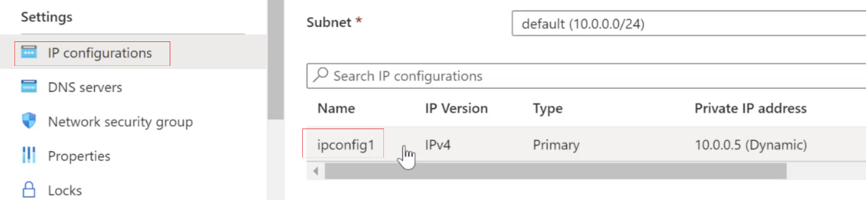

|  |  |
| --- | --- |
|  | And I'm going to go ahead and create a standard SKU load balancer. And for that, we have to go out and ensure that the assignment of the private IP address is made has static. |

**Step 3:** Create a new public IP address under resource group, that need to assign to Load balancer. Choose standard SKU.

**Step 4:** Create Load Balancer. Choose same location as VM is. Choose SKU as standard

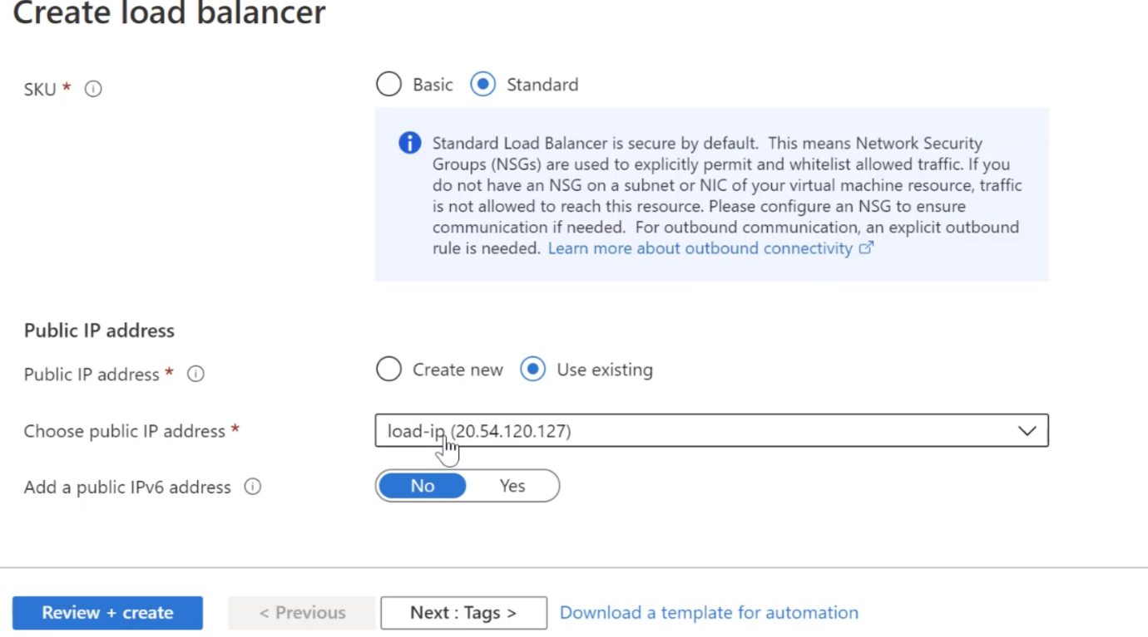

**Step 5:** Now configure the load balancer. Go to Backend Pool -> Add Backend Pool (which basically contains all virtual machines)

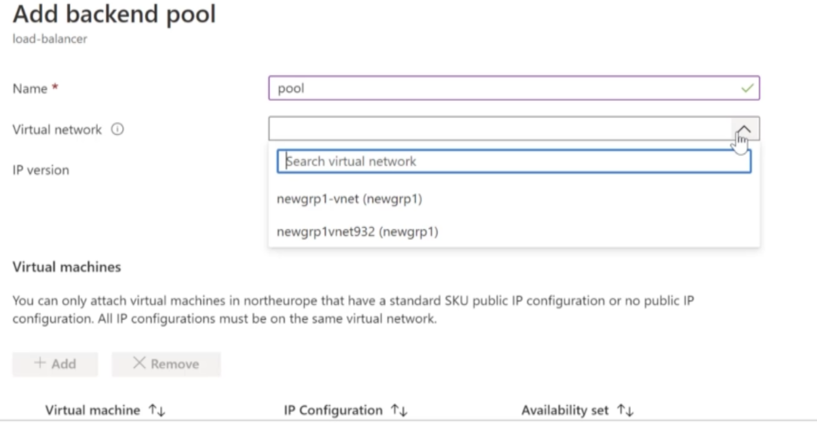

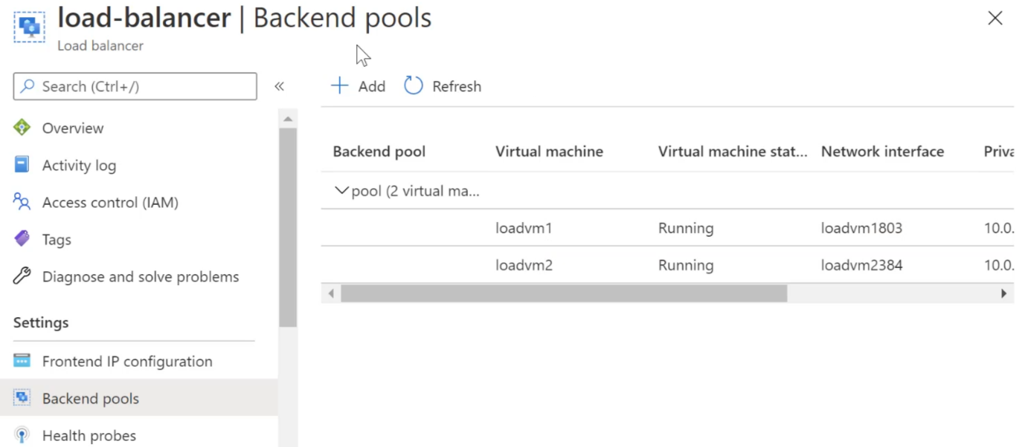

**Step 6:** Now Add Health Probe - So this allows the load balancer to understand better the backend voting machines are healthy or not.

**Step 7:** Now Add Load balancing rules - load balancing rule will basically go ahead and direct the traffic which comes on the frontend IP address of the load balancer on port 80 of the load balancer.

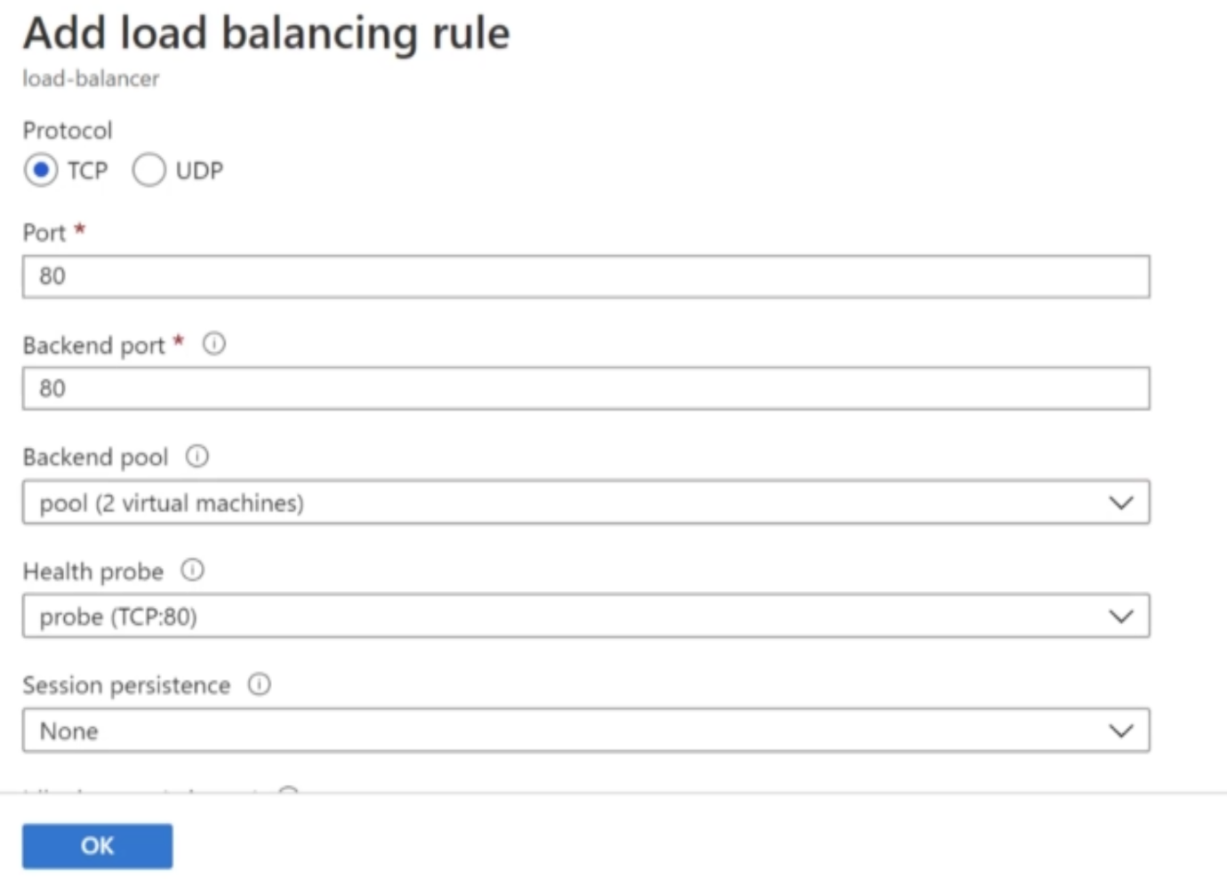

**Step 8:** Now browse the public IP od load balancer -> it will redirect to IIS hosted application to any one VM.

1. **Azure Virtual Machine Scale Set:**

Let's say that you have an application being hosted on a virtual machine and you have users who are going ahead and accessing this application from, let's say, the Internet.

Now, let's say that the load on the application is increasing. The resources are now being utilized to a high extent on this virtual machine. Let's say now that the CPU off this virtual machine is going beyond 90 percent, this might actually degrade the performance of the application. So you can do to scale out the VM.

So instead of doing this in a manual approach, what you can do is that you can go ahead and use virtual machine skill sets. So this is a service that can go ahead and automatically spin up identical voting machines based on demand.

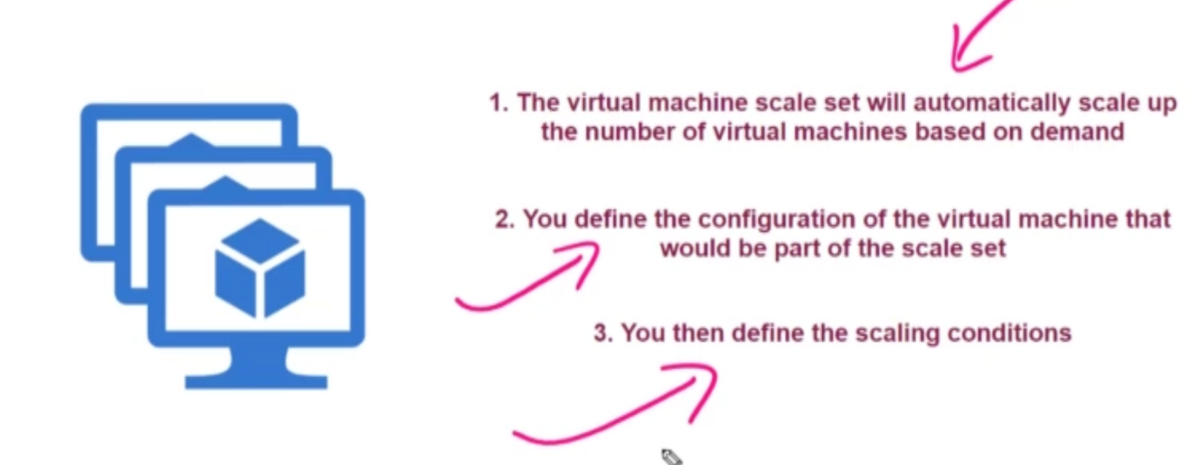

**Note:** The other advantage of the VMSS service - It can go ahead and integrate with your load balancer service. So, let's say the virtual machine scale-set goes ahead and creates two virtual machines, they can be automatically placed behind and as your load balancer, and this load balancer distribute the traffic between these VMs.

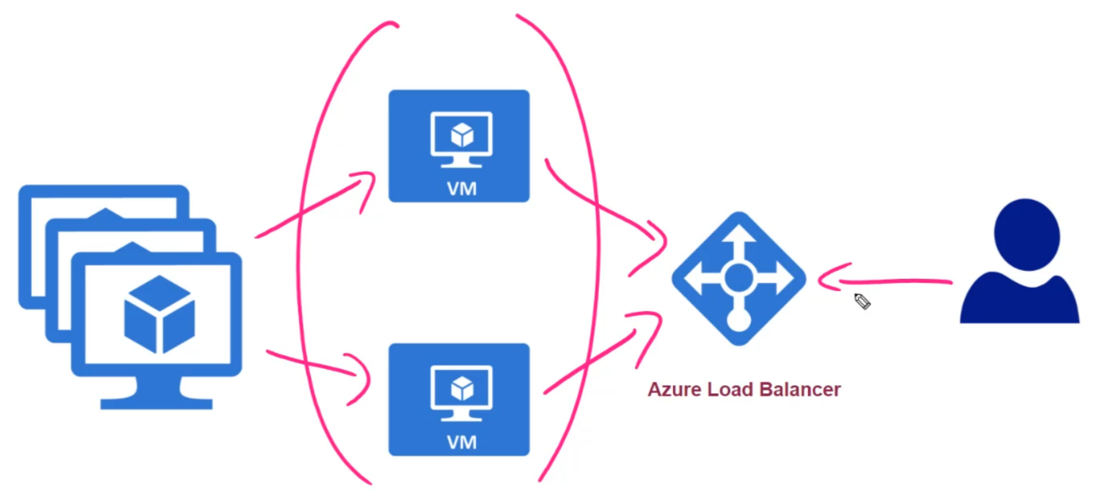

**Note:** Now, please know that it is your responsibility to ensure that your application gets installed automatically on the machines that are spun up as part of the scale set. There are different ways of doing this. - You can use features such as custom script extensions to publish your application on the virtual machines as part of the virtual machine scale set.

**Step 1:** Search new resource (Virtual Machine scale sets) -> Create VMSS

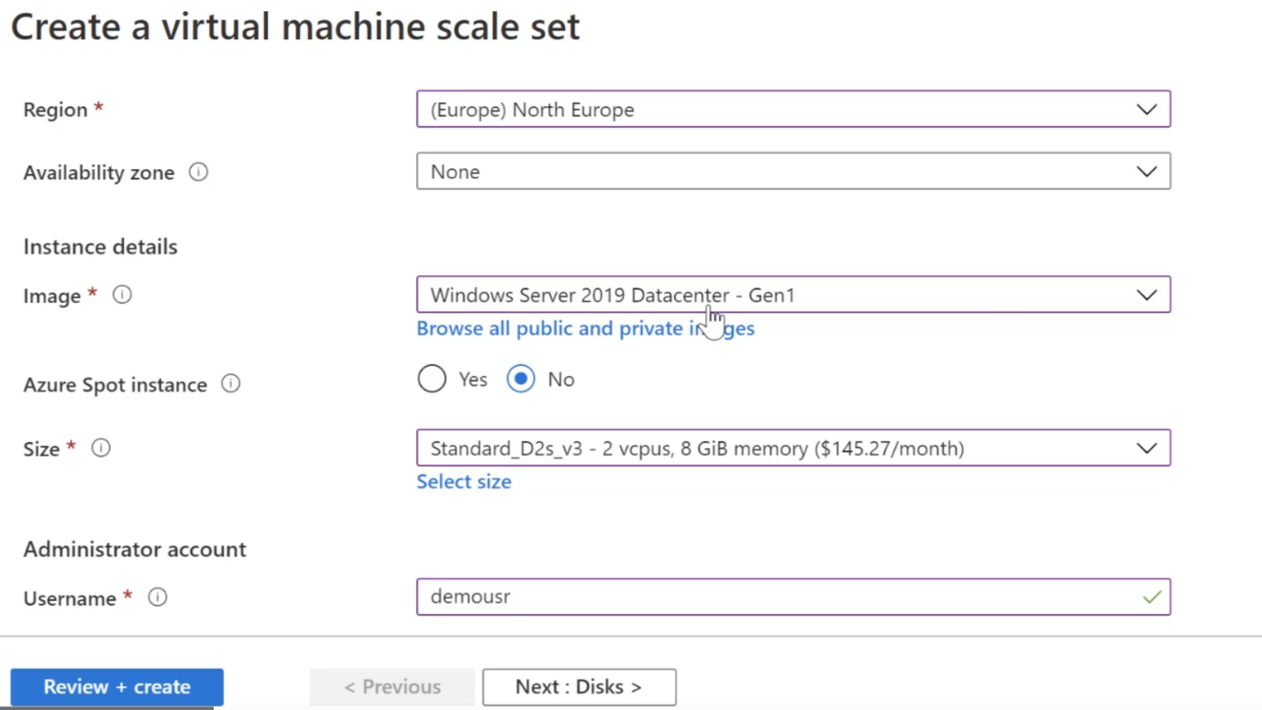

**Step 2:** Now go to networking -> create a new virtual network for the virtual machines which are sitting house, part of the scale set.

Now there'll be a network interface that is a sign onto each of your virtual machine. Now, I want to go ahead and click on this edit button over here. So I want to go ahead and allow public inbound ports. So I want to ensure that I allow traffic on both it and also allow traffic on the RTP boat

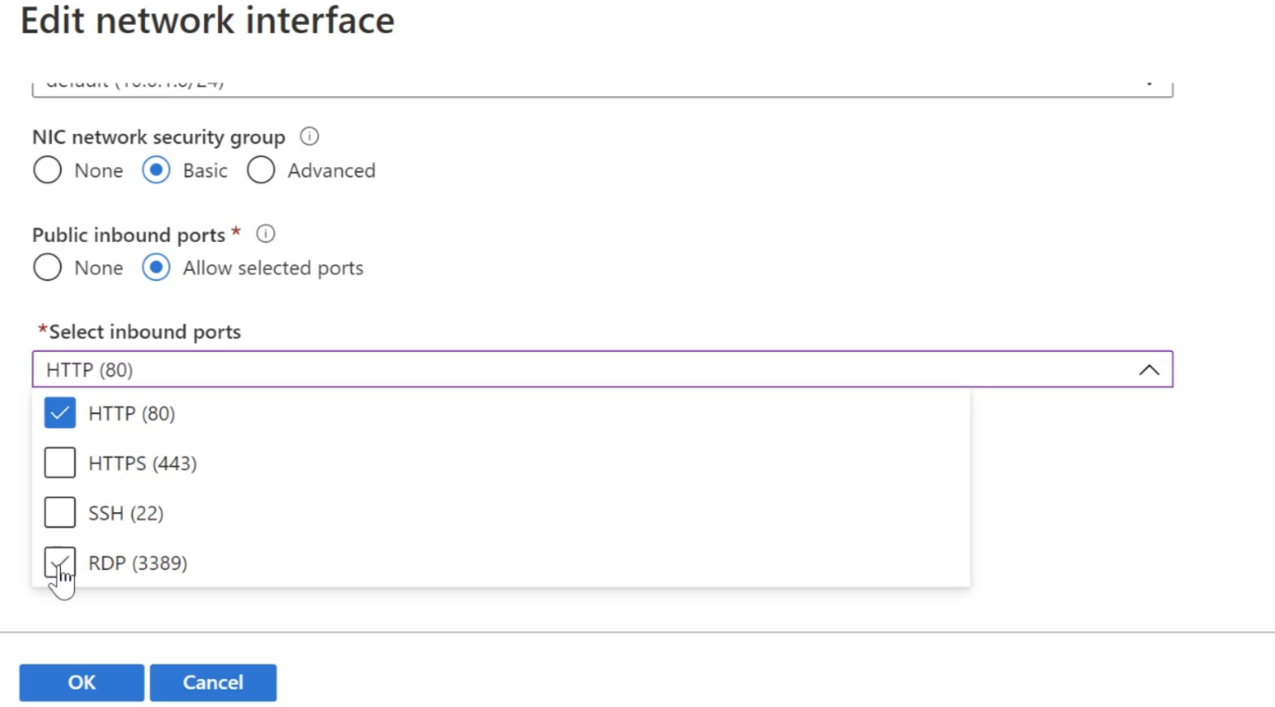

Now, over here, we have the ability to use a load balancer

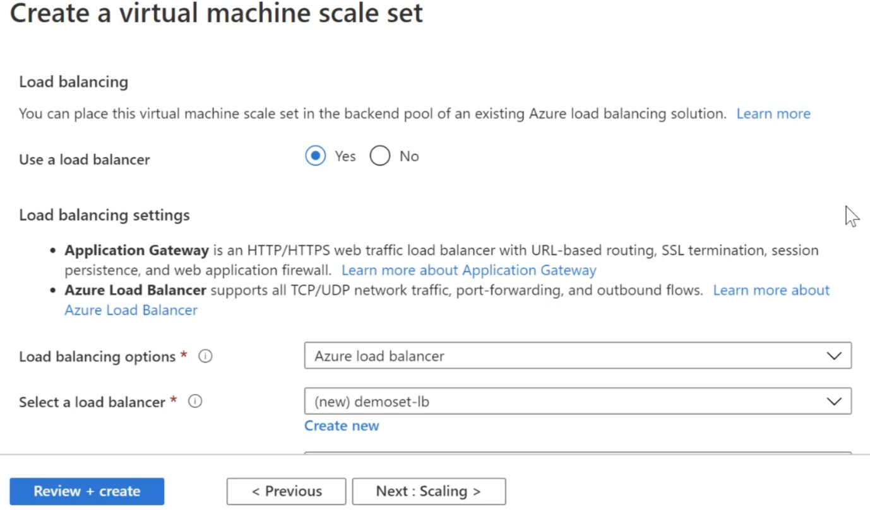

**Step 3:** For the application health monitoring of a virtual machine scale set- Enable the Monitor application health.

So over here, the skill set is going to go ahead and monitor the health of your virtual machines.

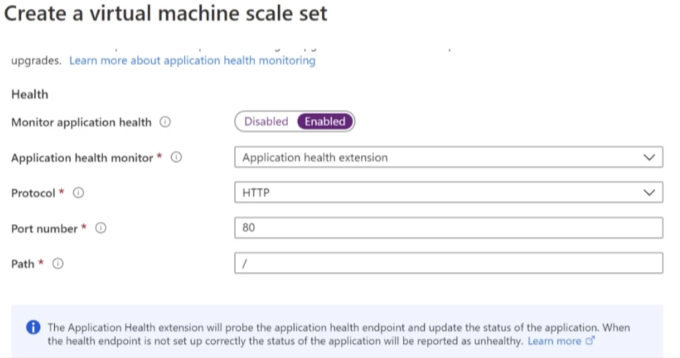

If nothing is running, then it's going to go ahead and mark the virtual machine as unhealthy.

**Step 4:** You can enable automatic repair policy – It actually check the health of VM and if VM is unhealthy then - Now, with the automatic repair policy, what the skill set will do - this will actually go ahead and de-allocate this virtual machine and then spin up a new virtual machine to take its place.

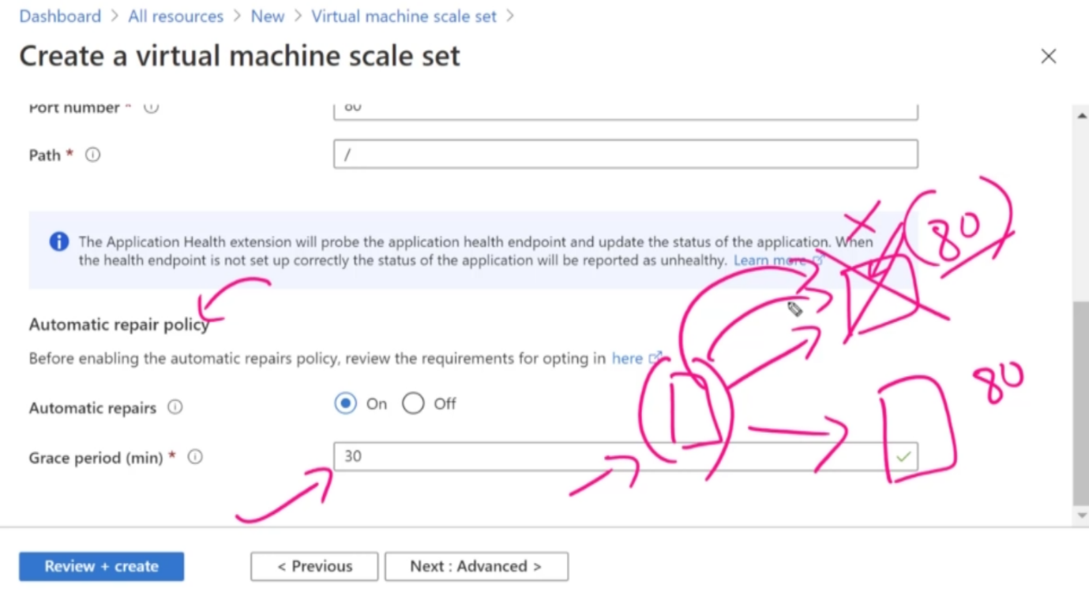

Now, there is this grace period of 30 minutes or so in 30 minutes. If it still is not working, then it will go ahead and basically spin up that new virtual machine.

**Step 4:** Now, we are going to go ahead and install Internet information services with the help of custom script extensions.

So I've gone ahead and created a storage account and upload that Polish script file. Then use PowerShell commend to tun the script by below commands.

1. Add the following to a file named script.ps1 in storage account

Add-WindowsFeature Web-Server

Set-Content -Path "C:\inetpub\wwwroot\app.html" -Value "Computer Name $($env:computername) !"

2. Use the below commands in Azure Cloud Shell

$config = @{

"fileUris" = (,"https://artifactstore4000.blob.core.windows.net/script/script.ps1");

"commandToExecute" = "powershell -ExecutionPolicy Unrestricted -File script.ps1"}

$set = Get-AzVmss -ResourceGroupName "newgrp1" -VMScaleSetName "demoset"

$set = Add-AzVmssExtension -VirtualMachineScaleSet $set -Name "customScript" -Publisher "Microsoft.Compute" -Type "CustomScriptExtension" -TypeHandlerVersion 1.9 -Setting $config

Update-AzVmss -ResourceGroupName "newgrp1" -Name "demoset" -VirtualMachineScaleSet $set

**Note:** Now please note that when the virtual machine skill set adds new virtual machines, the custom script extension will install automatically.

It's only because we already have one virtual machine that has been spun up as part of the scale set and this was done without the custom script extension.

That is why we have to go ahead and perform below process.

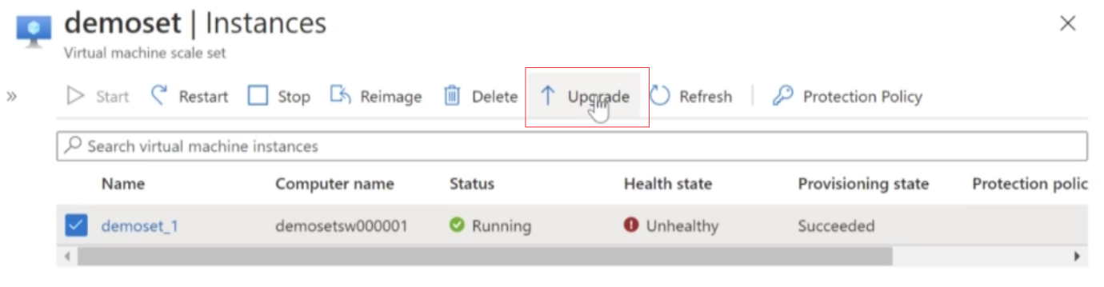

**Step 5:** You can setup the scaling conditions

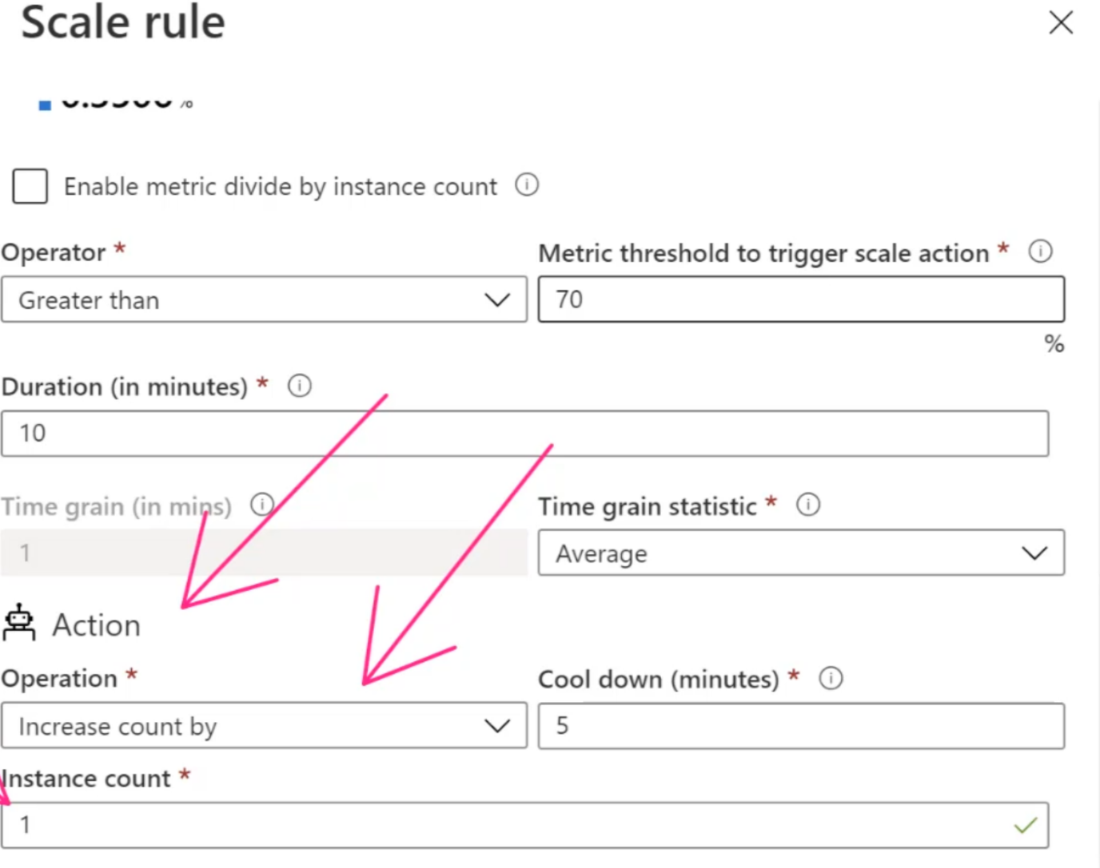

1. **Connect Virtual Machine doesn’t have public IP:**

Since VMs are the part of scale set and running behind the load balancer. So in order to go in and connect onto the virtual machine, we have to go on to the load balancer.

Choose load balancer created during Scale set -> Go to Inbound NAT Rules

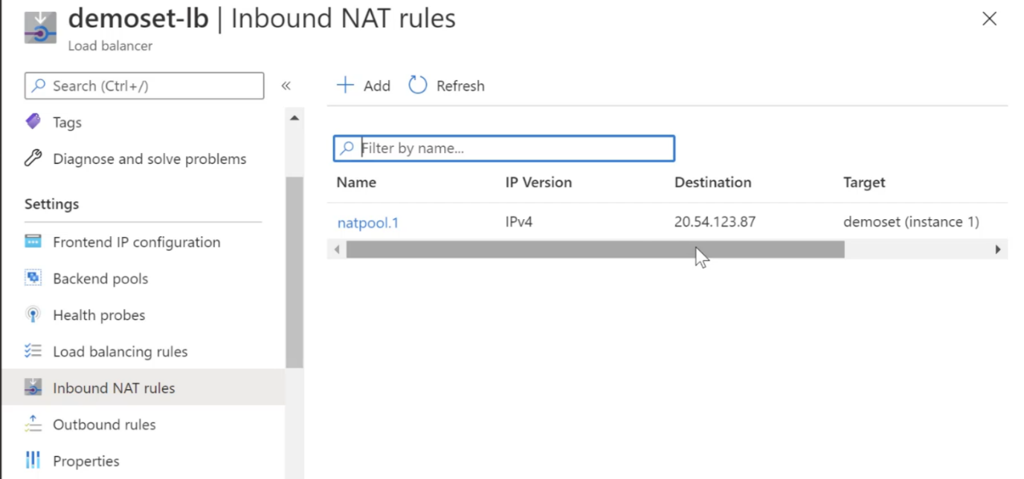

you should be able to connect on to that virtual machine using this IP address and using this number.

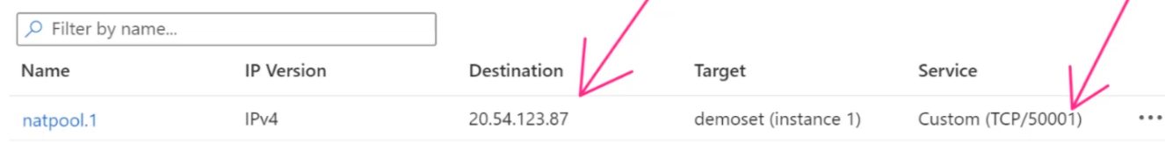

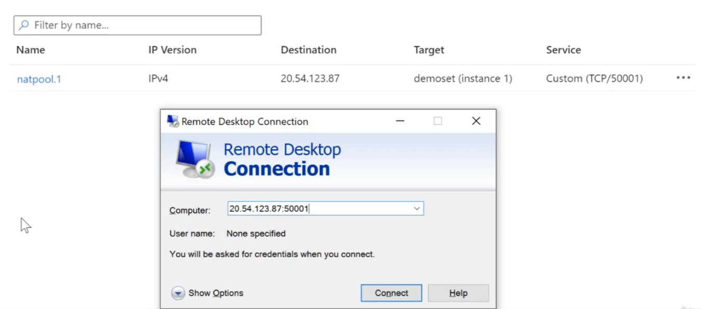

1. **Azure Monitoring and Logging:**

So one of the central services which is available for monitoring and logging is Azure monitor.

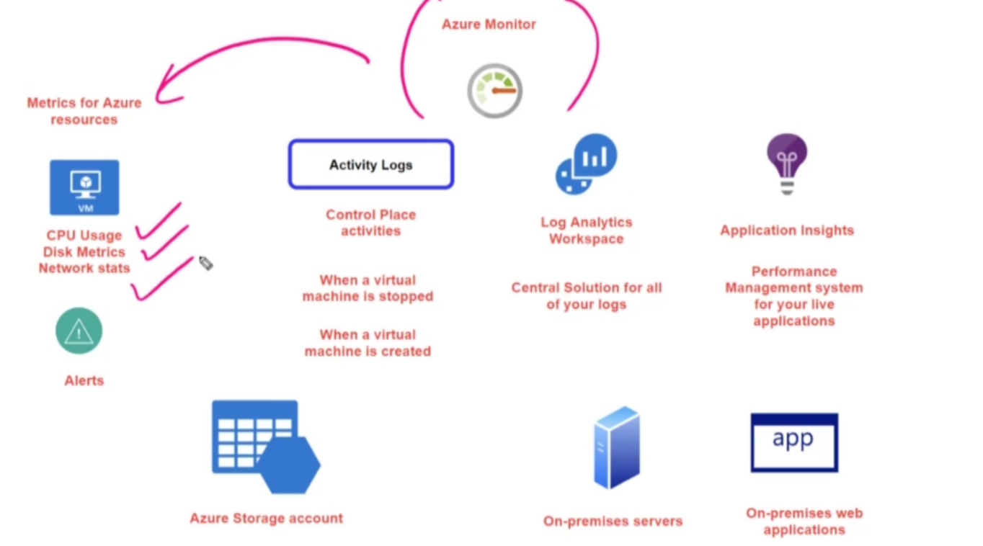

* 1. **Alerts in Azure Matrix**

**Step 1:** If you want to be notified, if, let's say, the utilization of a virtual machine goes beyond a particular threshold, then you can actually go ahead and create an alert.

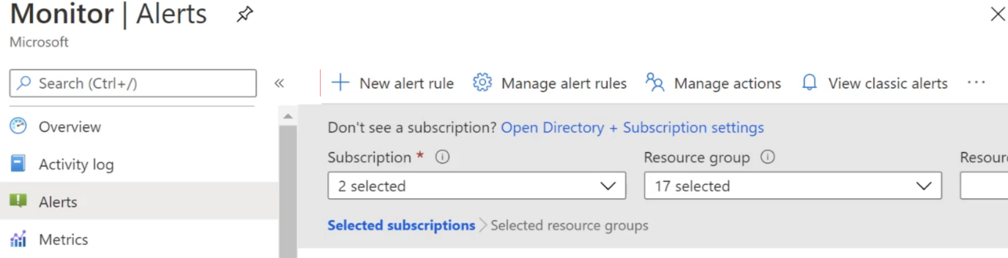

Click Add New Alert Rule -> Select the resource for which alert need to generate -> Select Condition

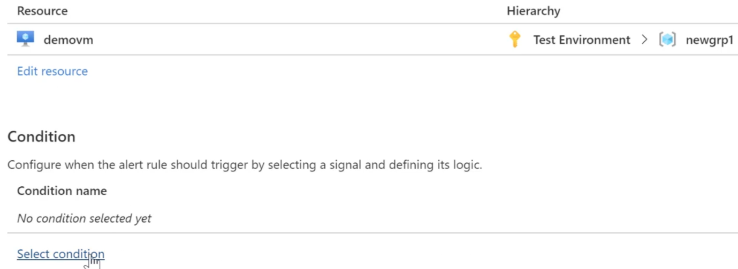

**Step 2:** Choose Signal Type:

Choose signal type as Activity Log: if you want to perform below activities

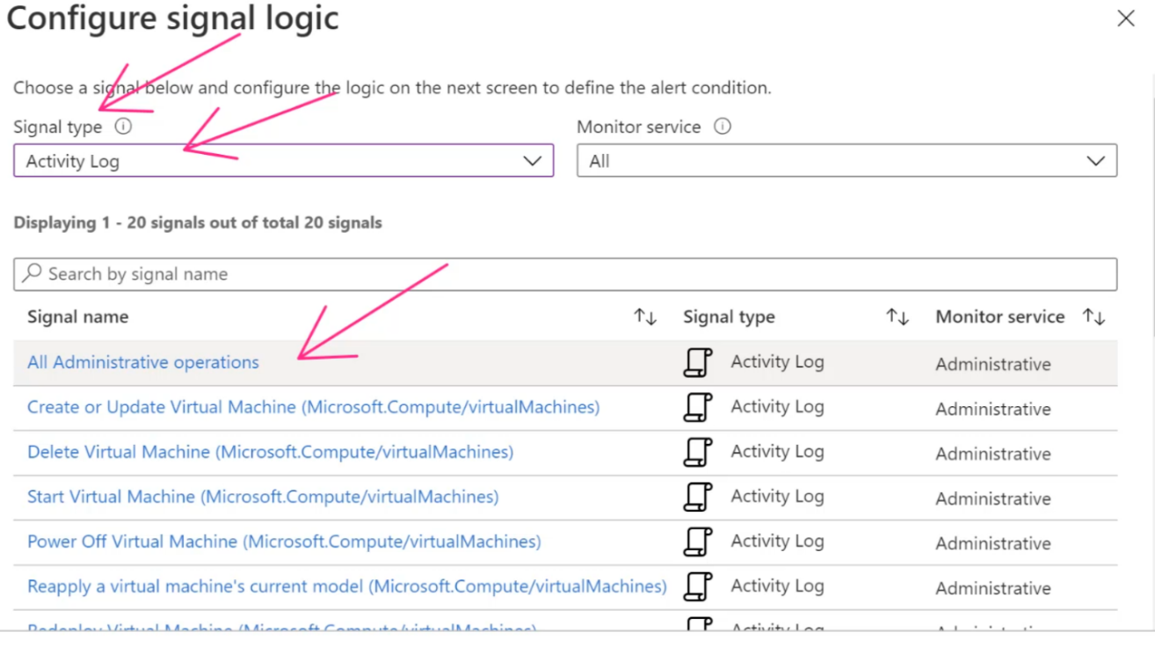

Choose signal type as Matrix: if you want to perform below activities

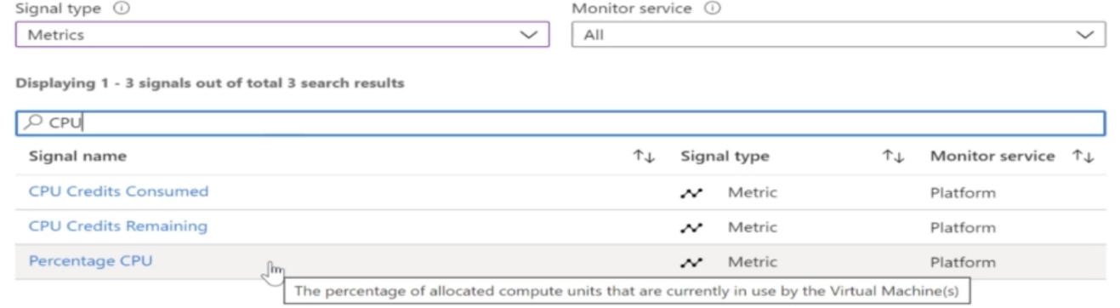

**Step 3:** Apply alert logic

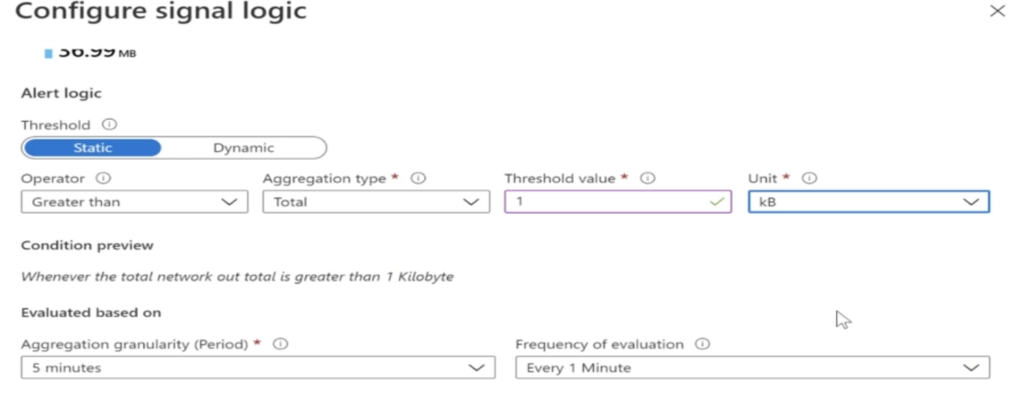

Aggregation Granularity: aggregated over five minutes, so it's going to take all the values during the last five minutes and based on this aggregated value, it will then be evaluated.

**Step 3:** Select and action group - So an action group basically means that what exactly are you going to do if the alert is generated?

* Do you want to send Email Notification?
* Do you want and run function?
* Do you want to trigger Logic Apps?

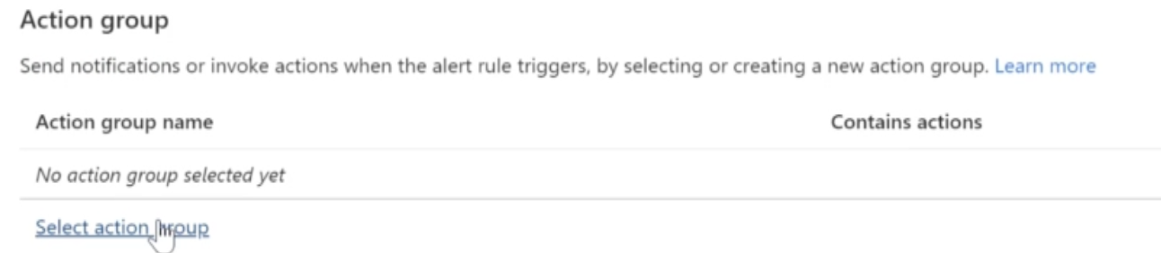

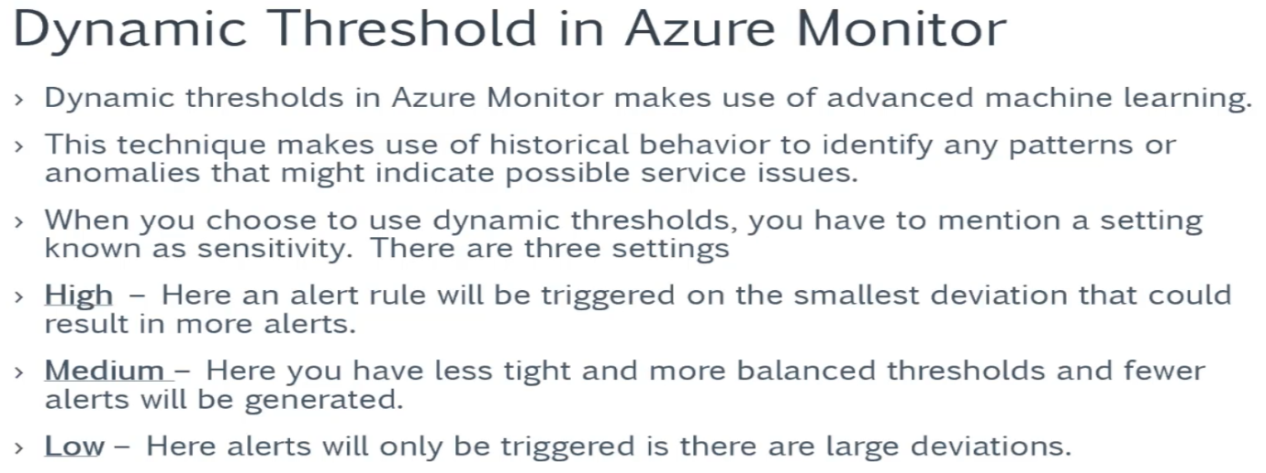

* 1. **Invoke Azure Function based on the Alert:**

I want to go ahead and show you how you can actually invoke and an your function based on an alert that gets triggered in your monitor.

Agenda -> want to generate alert on VM and want the data to be sent about this virtual machine onto an azure function.

Search for Function App -> create new function ->

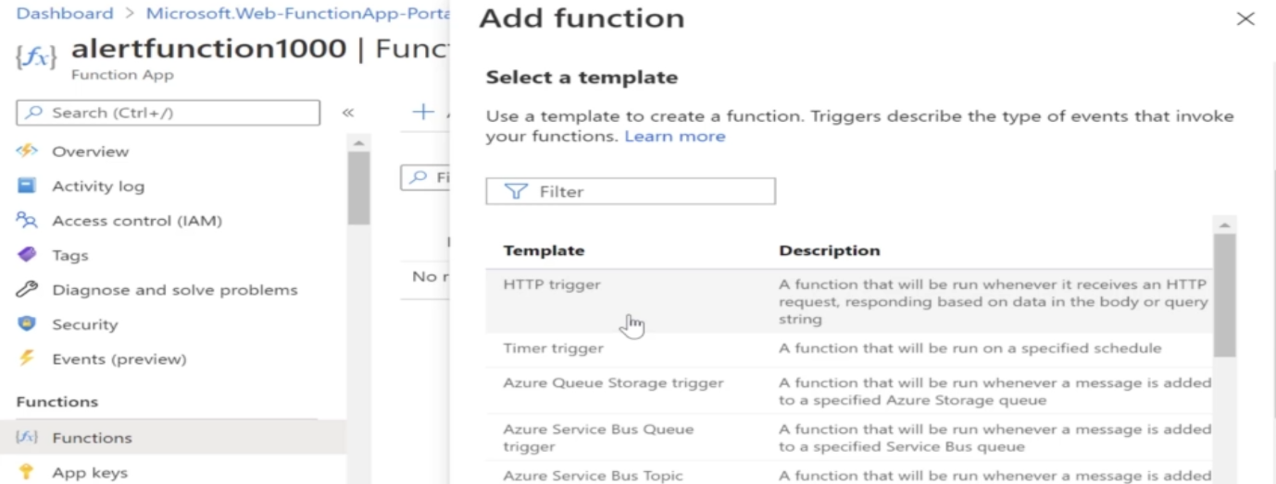

Create an Azure Function as PowerShell. And then enter the following code in the Function

1. using namespace System.Net
3. param($Request, $TriggerMetadata)
5. $Request | ConvertTo-Json | Write-Output

**Step 2:** Create a new Alert and setup the Signal Type = Matrix and select Network Outage for which alert logic need to set.

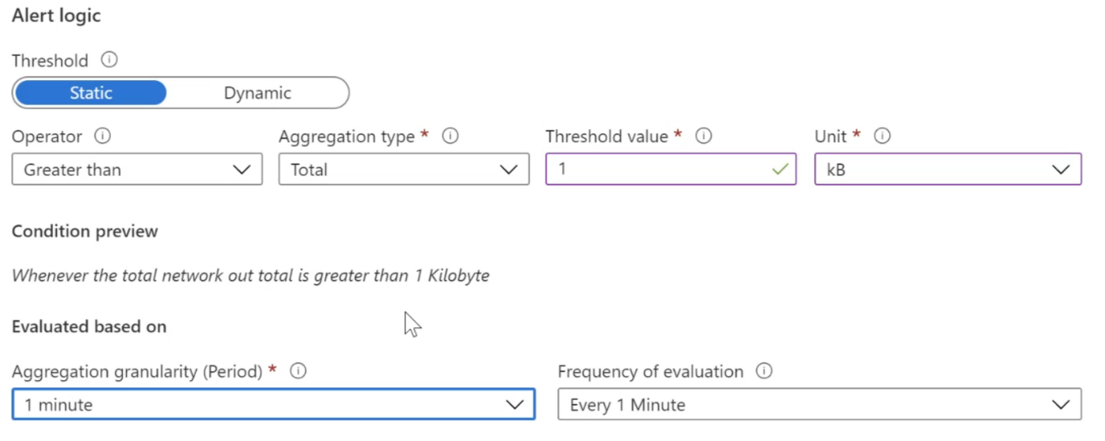

**Step 3:** Create a new Alert Rule-> choose Action Type = Azure Function

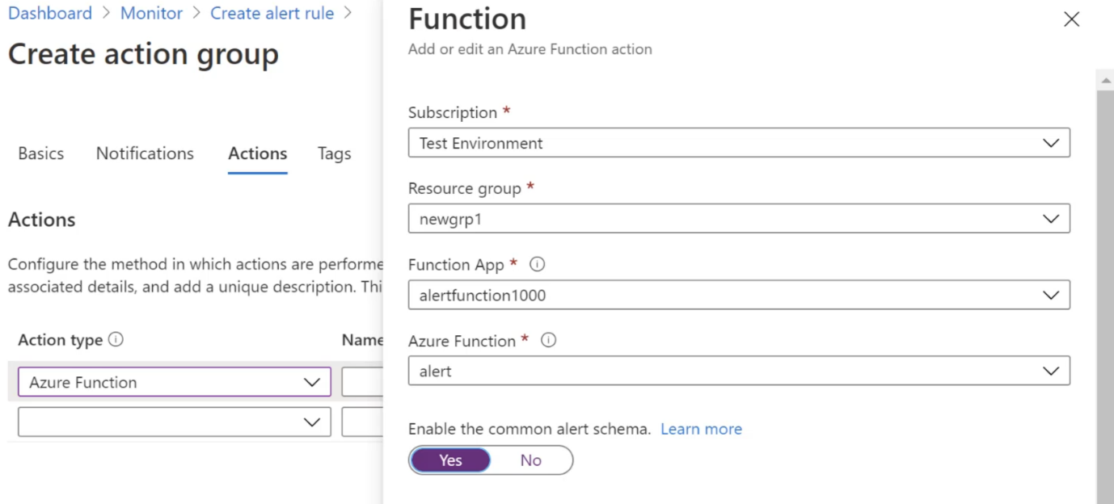

* 1. **Automatically stop the virtual machine which activated and triggered an Alert**

We are going to see how to run a Runbook, which will be available as your automation account based on it a lot that will be triggered in your monitor.

**Step 1:** First go to All resource and find Azure Automation –Create New Automation Account

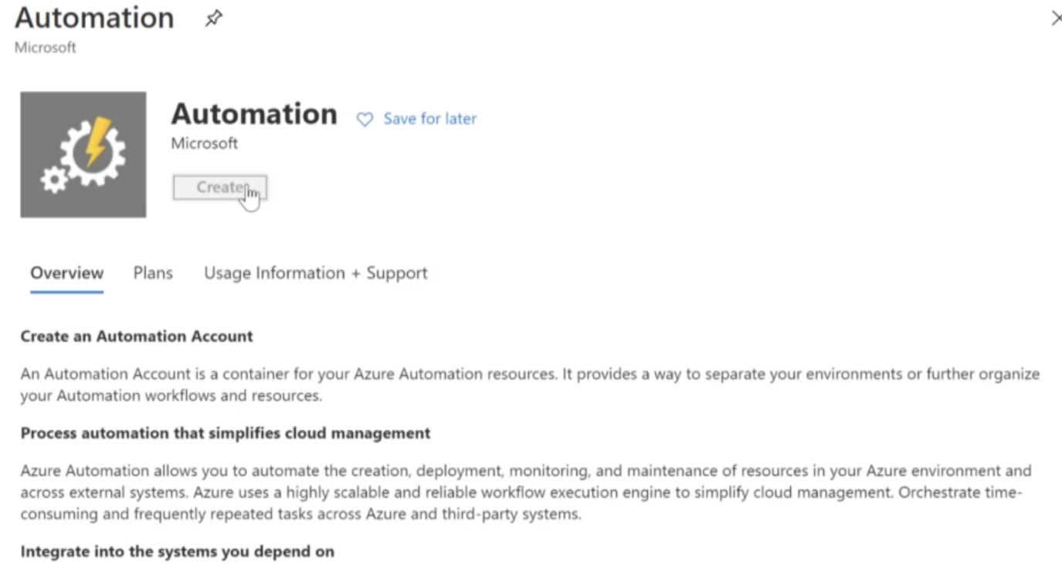

**Step 2:** Once Automation account created -> go to Module Section -> Browse the Gallery (Click on …..) -> Install some PowerShell Modules as shown below.

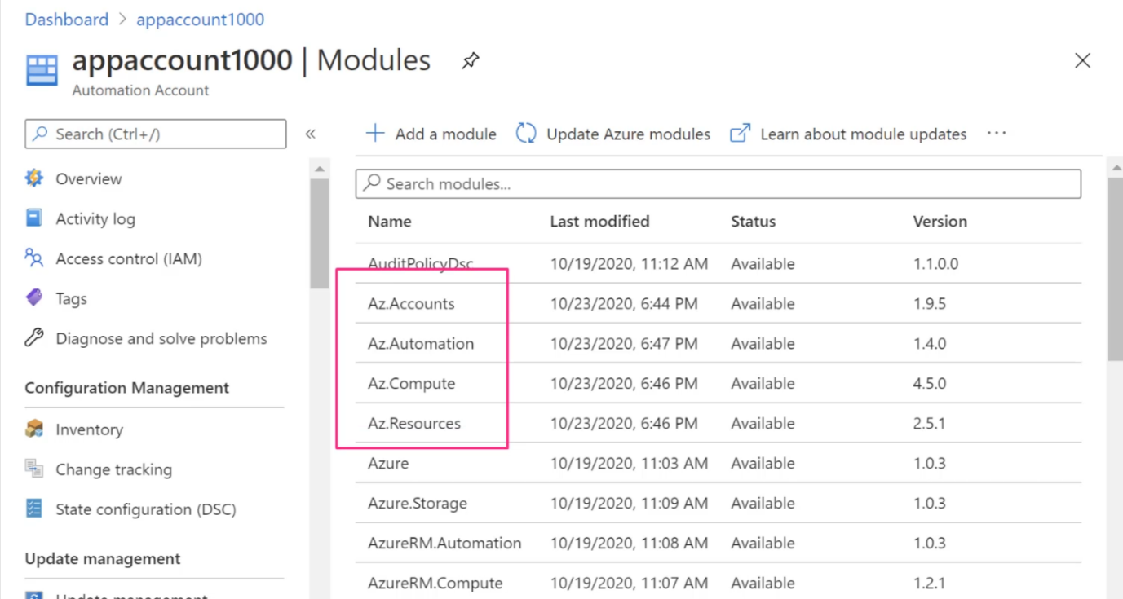

**Step 3:** Click on Runbook -> Create Runbook ->Enter the below code and Save

**Create a runbook based on PowerShell and then enter the following code**

1. param (
2. [object]$WebhookData
3. )
5. if ($WebhookData -ne $null) {
7. $WebhookBody = (ConvertFrom-Json -InputObject $WebhookData.RequestBody)
8. $Context = [object]$Body.context
9. $AlertContext = [object] ($WebhookBody.data).context
10. $SubId = $AlertContext.subscriptionId
11. $ResourceGroupName = $AlertContext.resourceGroupName
12. $ResourceType = $AlertContext.resourceType
13. $ResourceName = $AlertContext.resourceName
15. $ConnectionName = "AzureRunAsConnection"
16. $Connection = Get-AutomationConnection -Name $ConnectionName
18. Add-AzAccount -ServicePrincipal -Tenant $Connection.TenantID -ApplicationId $Connection.ApplicationID -CertificateThumbprint $Connection.CertificateThumbprint | Write-Verbose
20. Set-AzContext -SubscriptionId $SubId -ErrorAction Stop | Write-Verbose
22. Stop-AzVM -Name $ResourceName -ResourceGroupName $ResourceGroupName -Force
24. }

**Step 4:** Now go to Azure Monitor -> Create a new Alert -> Select the resource for which Alert need to generate (i.e VM) ->Select the Condition (example Azure Network Outage) -> Create Action Group (Choose Automation Runbook)

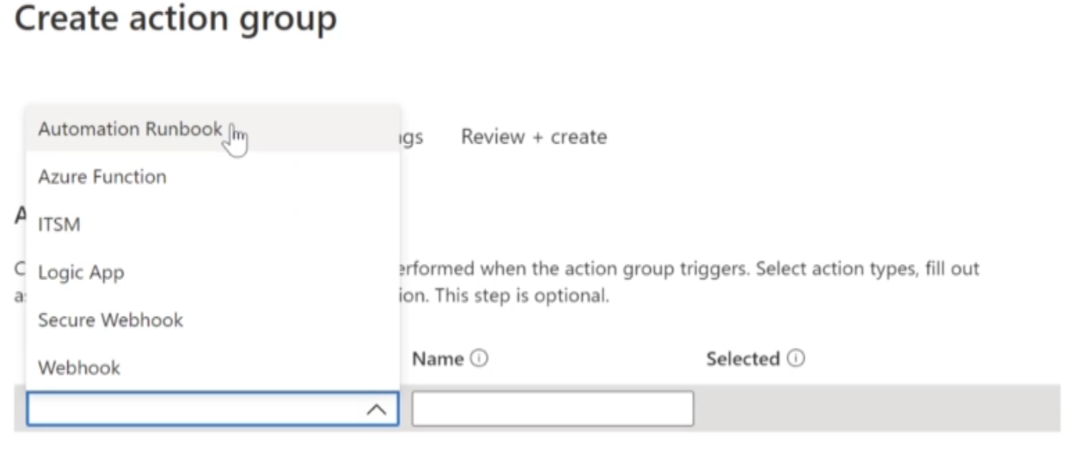

Finally Creation of Alert Done and runbook start Monitoring alert and stop VM.

* 1. **Other Monitoring Tools**

**Diagnostics extension:**

* this can be used for collecting monitoring data from the guest OS and also workloads that run on your virtual machines.
* You can archive the data onto Azure storage accounts.
* Here an agent is installed on the virtual machine via a Virtual Machine extension.
* So It can collect data such as event logs, performance and file based logs, IIS logs, .Net Application logs
* Select VM -> Go to Diagnostic Setting section in left panel -> Select storage account to store boot Diagnostic logs -> Enable

**Log Analytics Agents (Microsoft Monitoring Agents):**

* This agent can also be installed on your on-premise virtual machines as well.
* This can be used to collect monitoring data from the guest operating system and workloads that runs on Azure virtual machines, other cloud providers and on-premise as well.
* All of the data is collected in a Log Analytics workspace.
* Here a Log Analytics agent is installed via a Virtual Machine extension.
* This can go out and collect data such as event logs, your performance and file-based logs and also collect information about other insights and solutions.

You can use the following queries used in the previous chapter

// See the events generated in the last 12h , order by the TimeGenerated attribute and then see the count of events

Event | where TimeGenerated > ago(12h)

| order by TimeGenerated desc

| summarize count() by Computer

---------------------------------------------------------------------------------------------------------------

// makelist is used to pivot data by the order of values in a particular column.

Event| where TimeGenerated > ago(12h)

| order by TimeGenerated desc

| summarize makelist(EventID) by Computer

---------------------------------------------------------------------------------------------------------------

// makeset can be used to create a list on distinct values

Event| where TimeGenerated > ago(12h)

| order by TimeGenerated desc

| summarize makeset(EventID) by Computer

---------------------------------------------------------------------------------------------------------------

**Dependency agent:**

* This is installed along with Log Analytics agents
* This collects the data that discovered about the processes running on the virtual machine.

**Step 1:**

Go to your existing VM -> in monitoring section go to Insight -> Hit on Enable

What this is going to do is that it's going to go ahead and either choose an existing logs and its workspace or to go ahead and create a new logs on its workspace for you.

It's going to install the dependency agent so all the collection of data from the underlying virtual machine can be sent on to that log at its workspace.

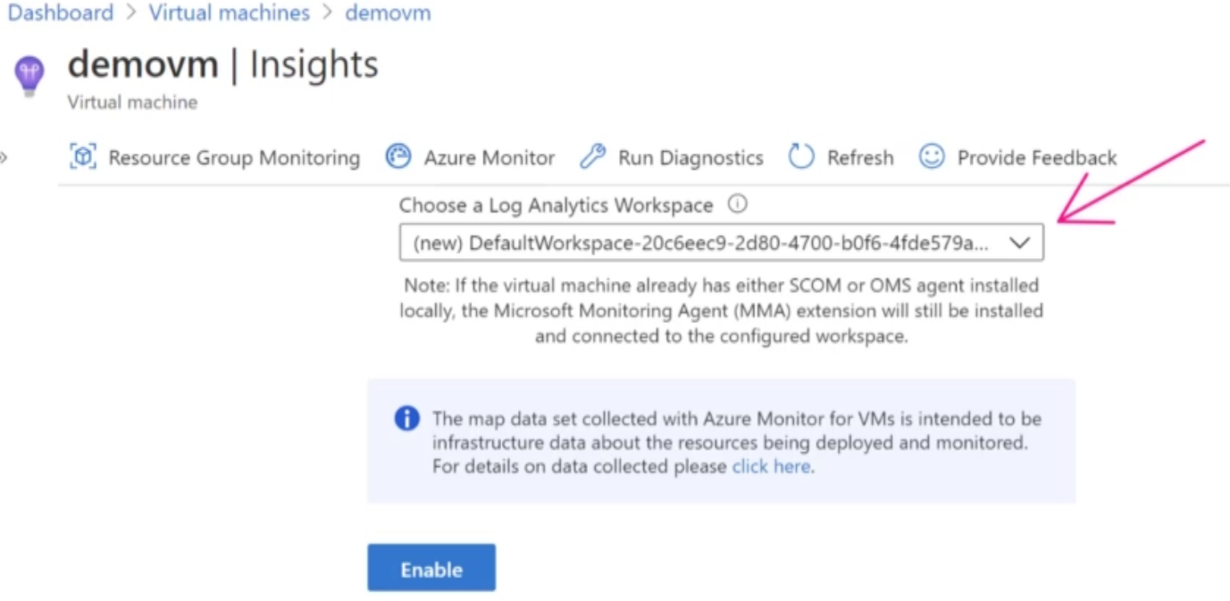

**Step 2:** Once it enabled, you can go back to Insight and can see the performance and other logs there.

1. **IT Service Management Connector (ITSM)**

Most of the times, companies might have only invested in their own I.T. service management solution. So, for example, they could be using a solution such as ServiceNow.

So if you want to go ahead and create work items in an external system based on alerts that are in your monitor, then you can go ahead and make use of an IT service management connector.

**Step 1:** Create a new resource IT Service Management Connector

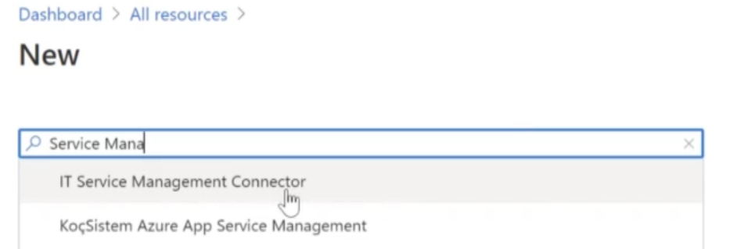

**Step 2:** You should have existing Log Analytics workspace or you can create a new workspace. So choose workspace and hit create.

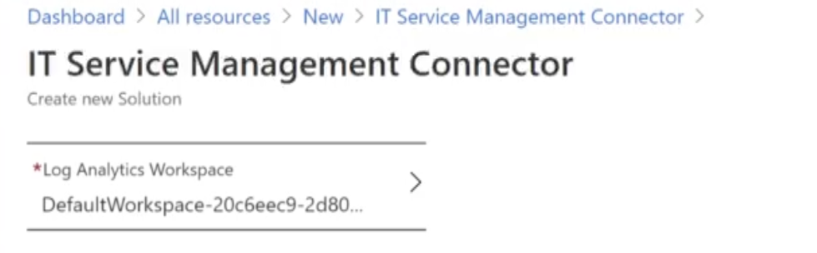

**Step 3:** Go to ITSM connection and click on Add

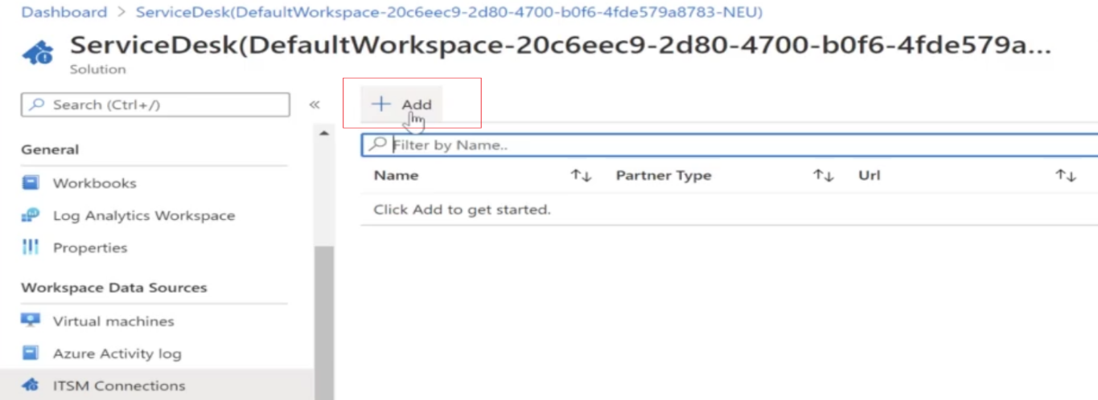

**Step 4:** Configure the connection details.

1. **Application Insights – Web Apps**

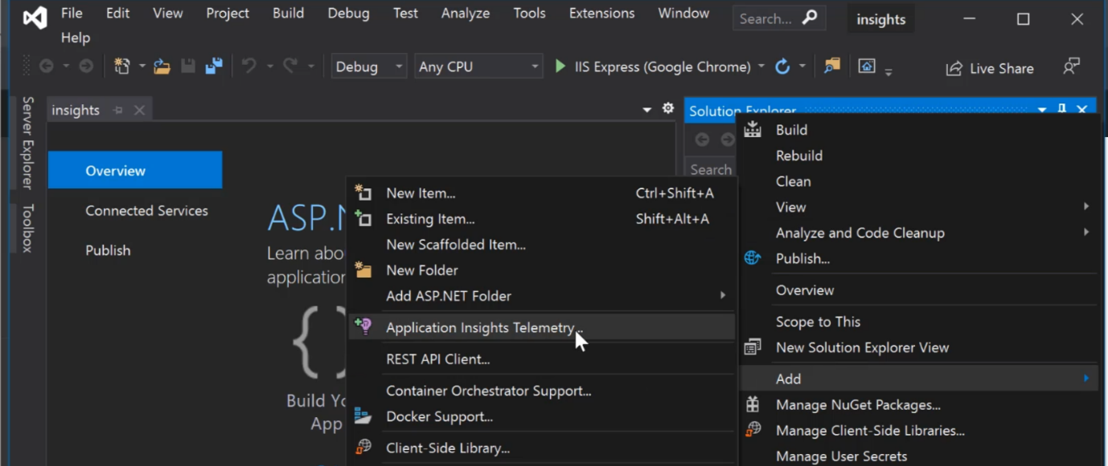

**Step 1:** Add the SDK to try out the local mood. So this is now going to install some packages as part of this particular project and enable application Insights.



**Step 2:** Run you web application andgo to your visual studio and follow the given below path and click on search, you will get all the telemetry data

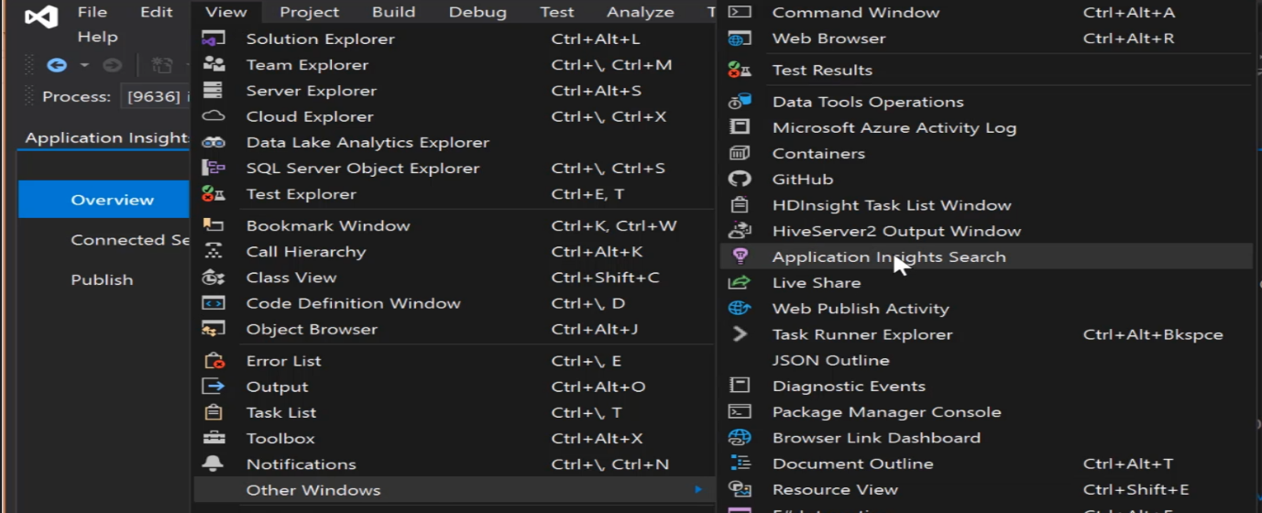

* 1. **Application Insights in Azure:**

Create a new Web App -> in Monitoring section -> Enable and create new Application Insights

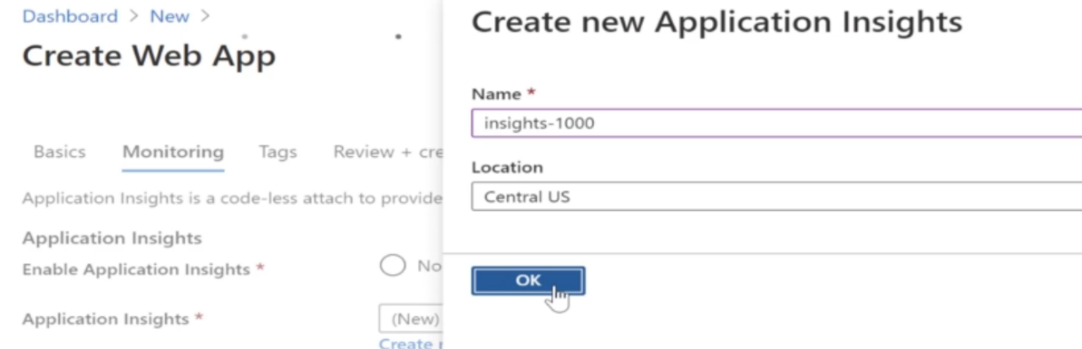

Publish your project in Web App

* 1. **Application Insights – Availability Test:**

If you want to monitor the availability of your web URL at regular intervals just to ensure that the link is reachable, or to ensure that the link is working.

Go to Availability section in Application Insights -> Add Test

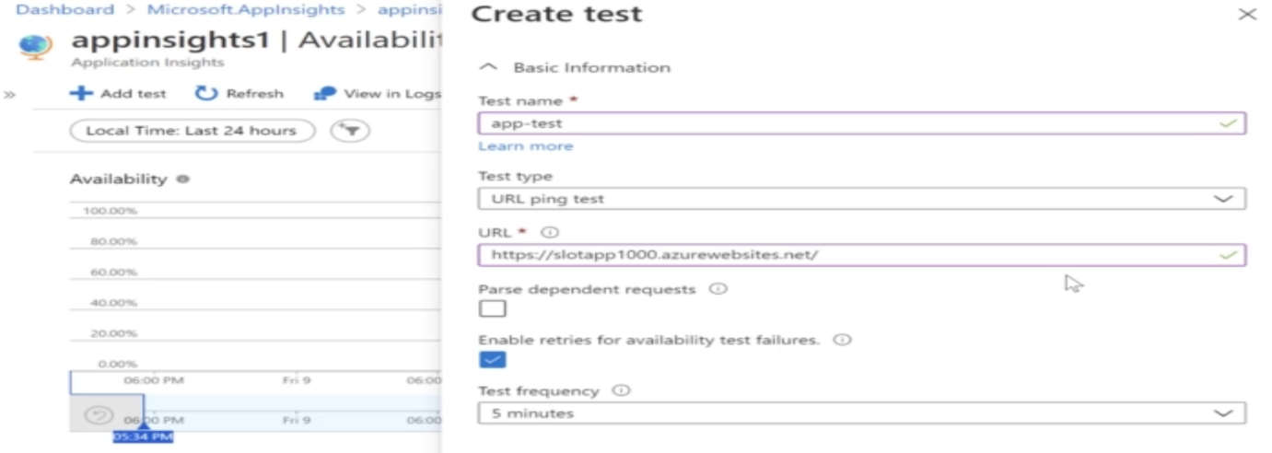

* 1. **Lab - Application Insights - Alerts - Azure Logic App – Resources**

Use the alert's, which are available with availability test and ensure that the alert can go out and trigger your logic App. (Lab 225)

* 1. **Lab – Azure Container Instances – Liveness Probe**

**Container Groups**

* This is nothing but a collection of containers.
* These containers get scheduled on the same host machine.
* They would share the same lifecycle, resources, local network and storage volumes.
* The deployment can be done via Resource Manager templates or a YAML file.

Sometimes the containerized applications which run for long periods of time , can go to broken states. These containers need to be repaired by restarting the container. You also have probes that you can define for Azure container instances.

* The liveliness probe can check whether the container is in a healthy condition or not and then restart the container as required.
* The readiness probe can be used to ensure the container is ready to handle incoming requests. Let’s say you have a database container that needs to load data first before taking on requests, you can make use of the readiness probe.

1. **Visual Studio App centre**

* This is another cloud-based DevOps solution.
* This is used for many buildings, testing and distributing your mobile based applications.
* You can go out and build applications that are based on either Android, iOS, Mac OS platforms.
* You can go ahead and configure App Centre to pick up your source code from GitHub, from Azure DevOps Repos from BitBucket often GitLabs.
* If you want to go ahead and distribute an application for testing an app center, you have to go ahead and do it via distribution groups.
* You can also test your applications on devices that are available with App Center.
* You can also distribute built applications to testers for testing.

To distribute the application for testing, you need to work with Distribution groups. You can create different types of distribution groups

**Private Distribution Groups –** This is the default type. Here testers can only be invited via email. The users added to these groups will receive an email notification to test the application if the release has been assigned to the group.

**Public Distribution Groups** – Here you can enable unauthenticated installs from public links.

**Shared Distribution Groups** – This helps to create groups that can share applications across a single organization.

If you want to distribute your builds using Visual Studio App Center, it is very important to sign your builds

1. **Test Plan**

You can create Test plan and inside it can create test cases and execute them against the application.

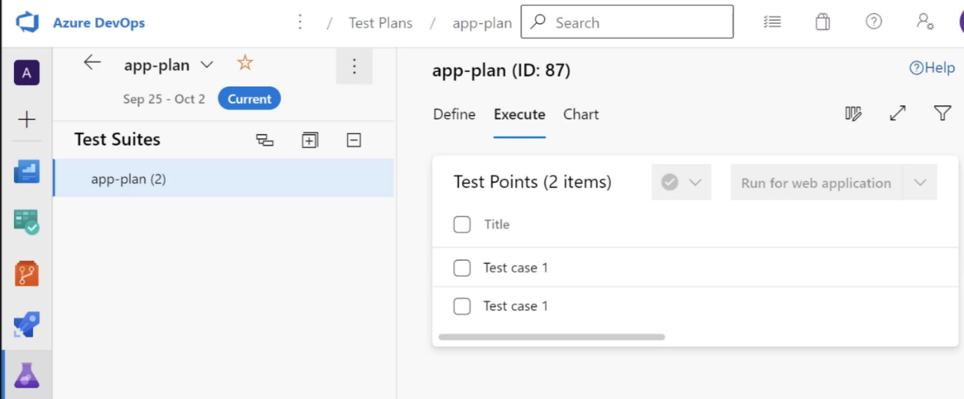

Once you select the Test cases and Run for the application -> you can set them pass or fail and create bug.

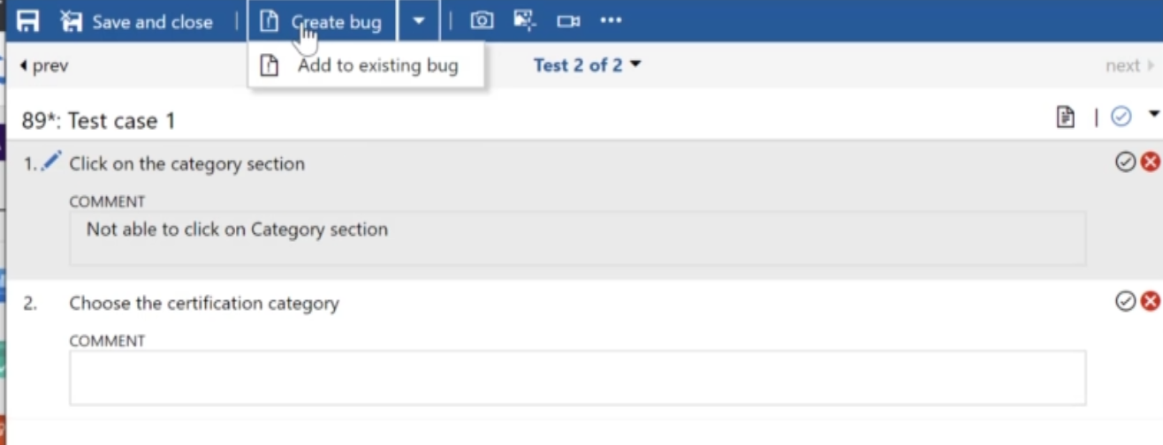

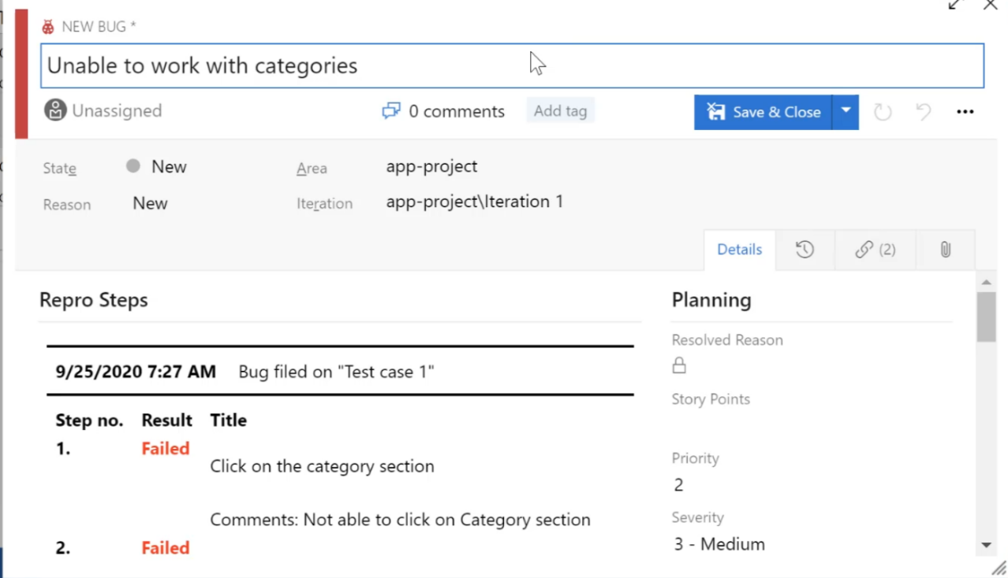

1. **Test and Feedback Extension:**

So if you have other stakeholders in your company that you want to go out and get feedback about an application that needs to be tested, you can actually go ahead and use an extension that is available in the browser that's known as a test and feedback extension.

Click and Install it in your browser

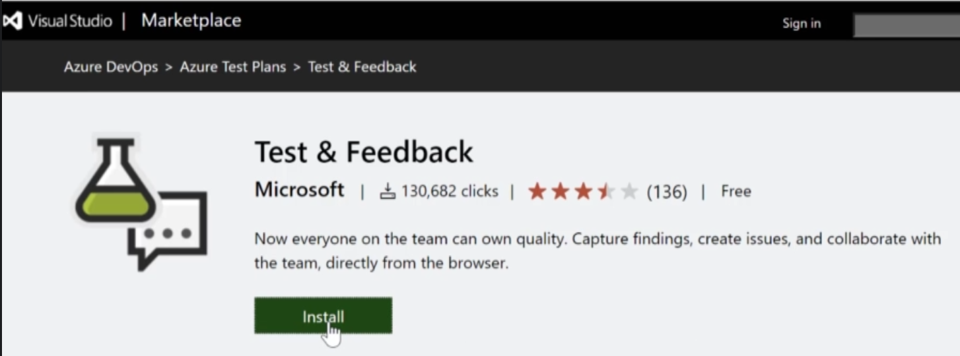

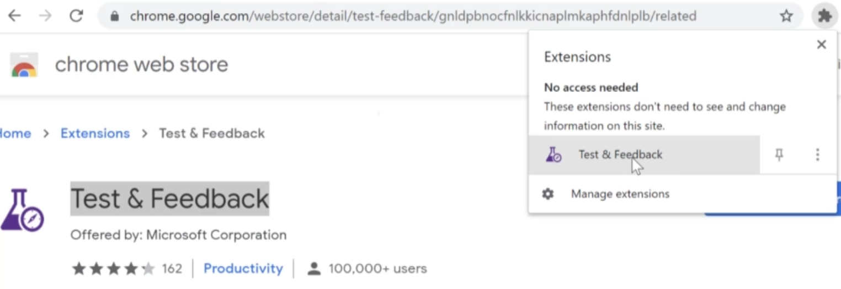

Go to Settings and provide DevOps URL – An then start testing you application by enabling session

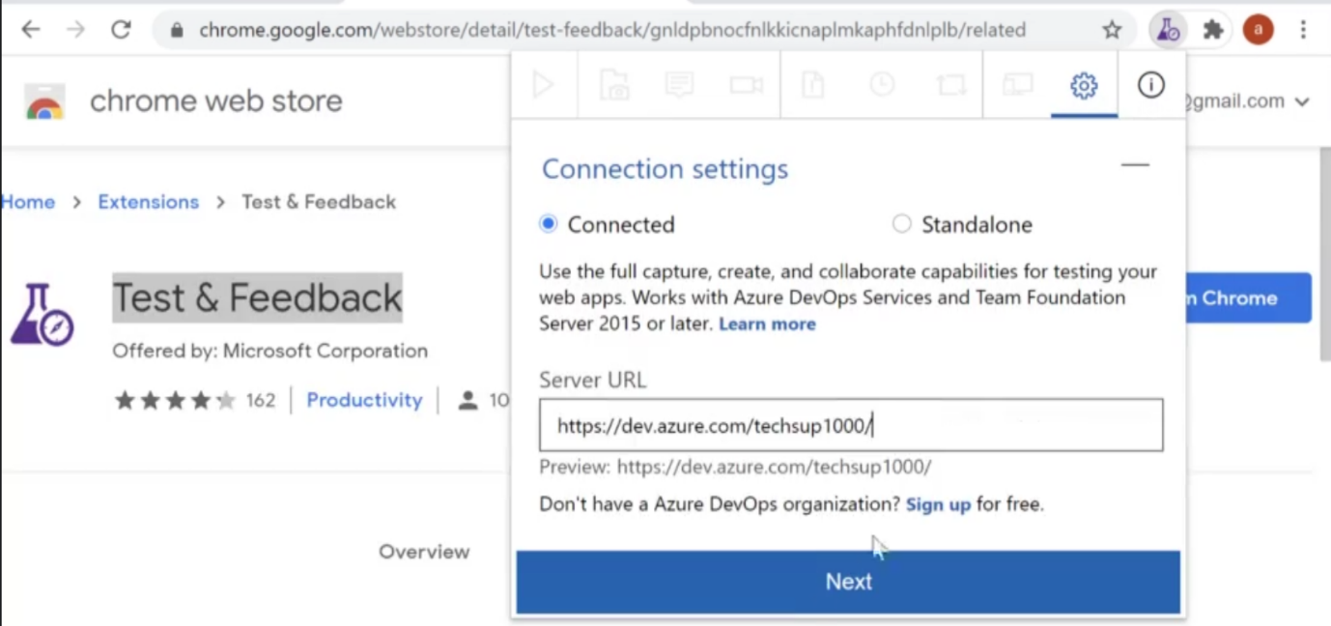

1. **Azure Artifacts:**

If a company wants to have their own repository in place for this company, artifacts which are important, they can go ahead and use Azure artifacts.

So in order to start publishing and consuming packages as your artifacts, the first thing that you have to do is to create something known has a feed.

You can also go out and create public feeds, if you want it as your Azure DevOps project.

**Step 1:** So let's go on Azure DevOps and let's create a feed in your artifacts.

Go to you Project -> Click Artifact in Left Panel -> Create Feed -> Then Click on Connect Feed

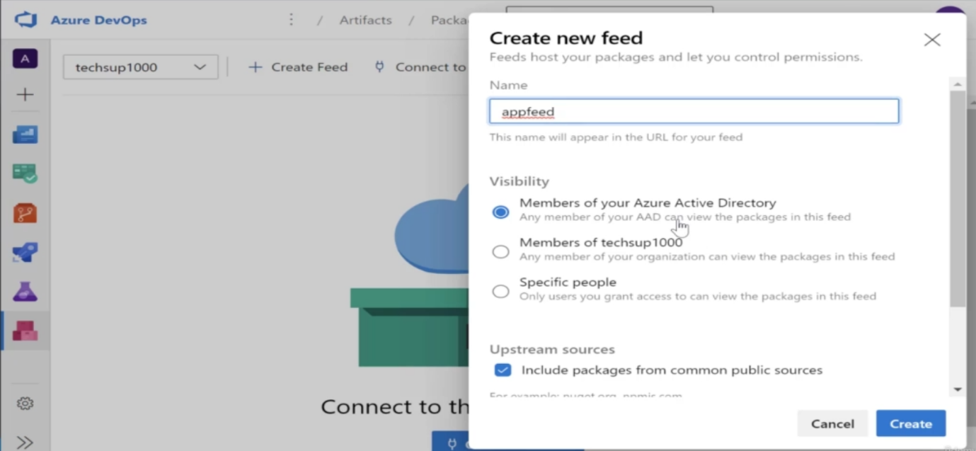

**Step 2:** Then Click on Connect Feed -> Here it will show you the different ways you can connect onto your feet.

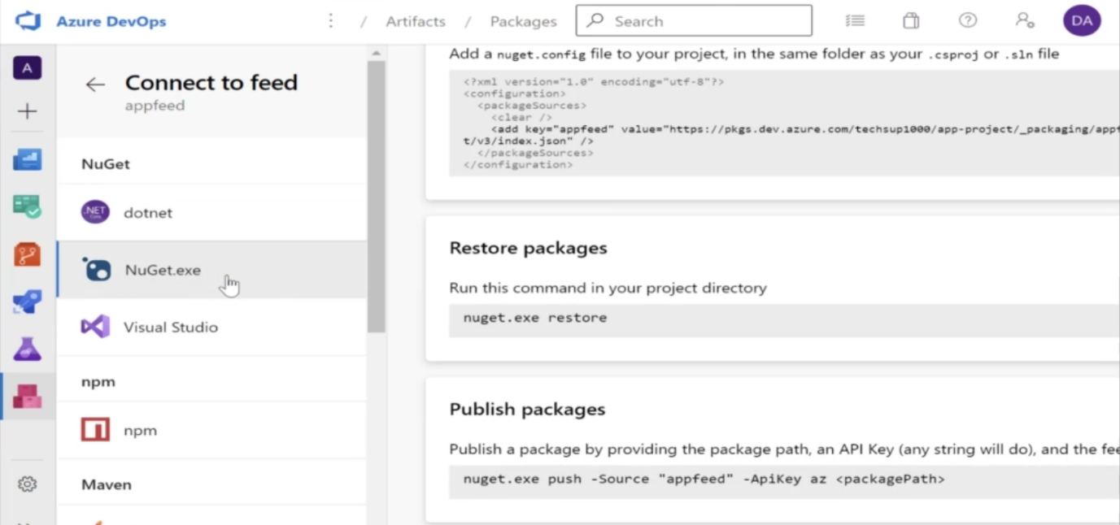

Here it will tell you how you actually have the ability to publish packages onto the feed using Dotnet, Nuget, npm etc.

1. **Publishing packages to nuget.org**

**Step 1:** In Visual Studio -> Create Project (Example- Class Library Project) -> Set the package Properties

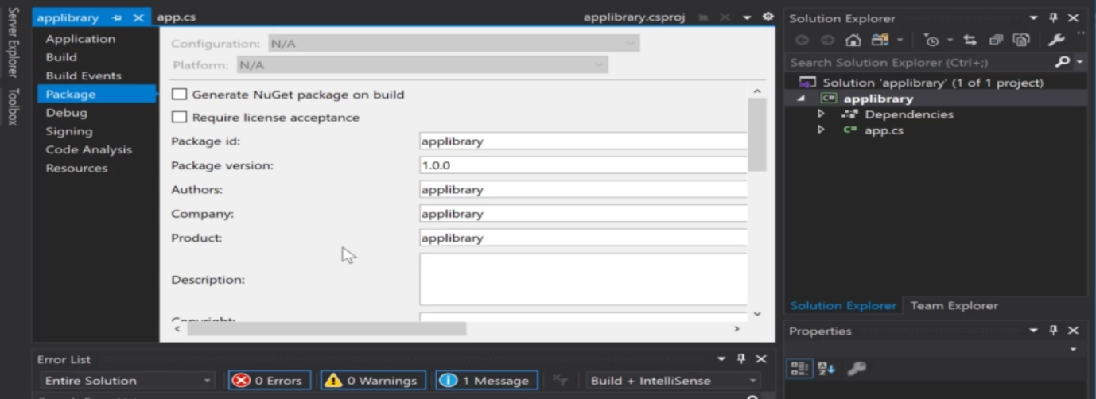

**Step 2:** Build the project -> Click on Pack

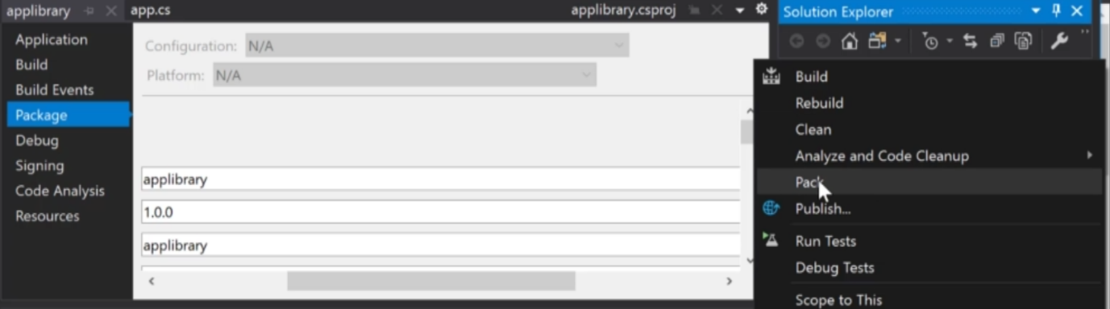

**Step 3:** So now over here in the debug folder of the product, you'll get something known as package that can now be published into Nuget.org.

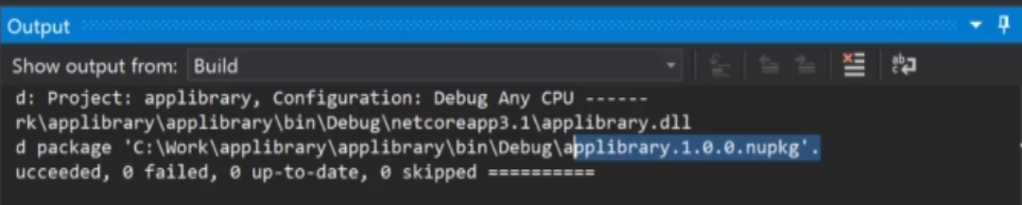

**Step 3:** First register into nuget.org -> Then go ahead start uploading your package into Nuget.org -> first thing you need to go is to create API key.

API key actually allows you to authenticate the Push process from your local machine on to Nuget.org.

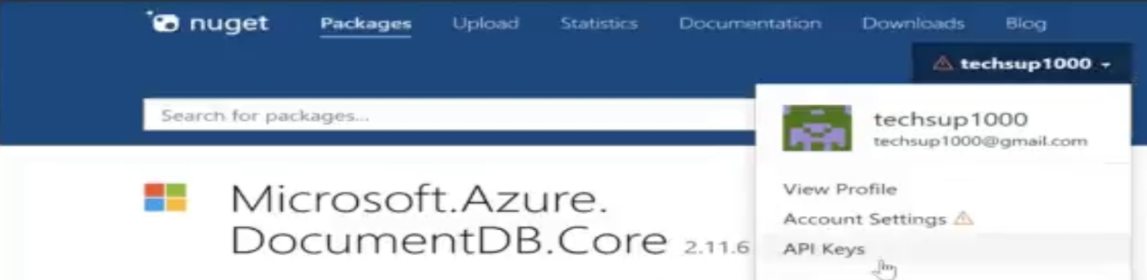

**Step 3:** Prepare command like below to push you package into nuget.org



In case if fail -> then might be your package id in visual studio is not unique -> change package id and do it again

**Step 4:** Now create new project -> Go to Nuget package Manager and search for your package and Install it in your project

1. **Publishing to Azure Artifacts**

In order to publish above into Azure Artifacts -> First download Nuget.exe -> For convenience copy the exe file into debug folder where your project nupkg exist.

**Step 1:** Create Personal Access token

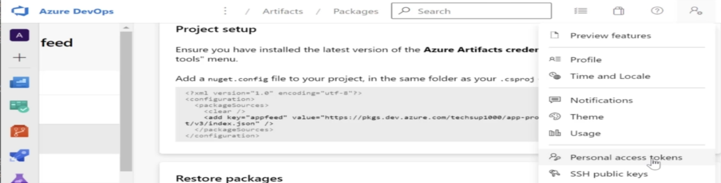

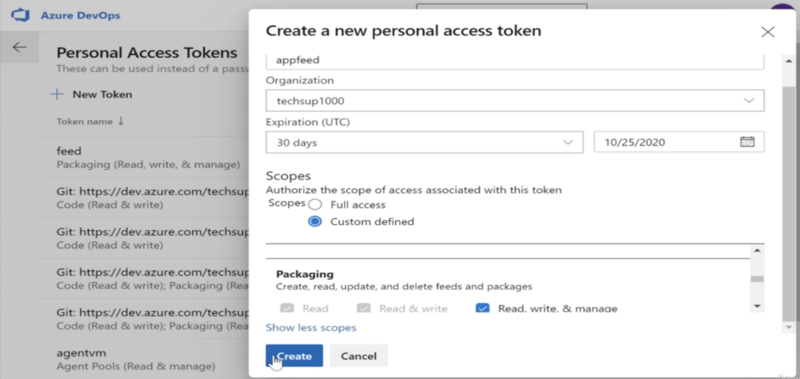

The following commands can be used as a reference for the previous chapter

* nuget sources list
* nuget sources add -Name demofeed -Source "https://pkgs.dev.azure.com/techsup1000/demo-project/_packaging/demofeed/nuget/v3/index.json" -username appfeed -password nu2lhnscukzokiqa7hbtb3wzpwmkzid4xfj4mru3cbkkazccejwa
* nuget push -Source "demofeed" -ApiKey az demolibrary2000.1.0.0.nupkg

1. **Azure Security Center**

Use Azure Security Center to improve the security posture of your Azure Account. Now, in the Overview page of Azure Security Center, if you have resources in place, it will first give you an overall score on what is your overall security compliance at the moment, it's not great for my particular resources.

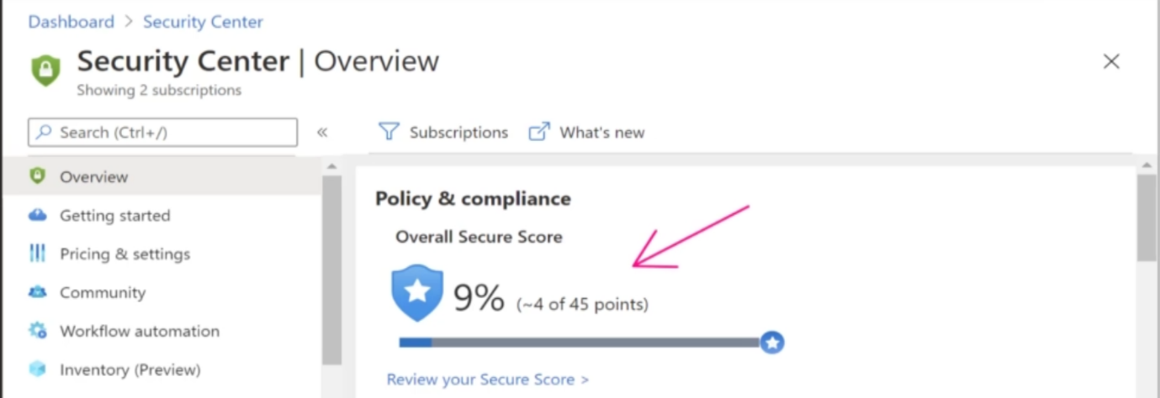

To view recommendation to improve security -> Scroll down a bit and go to Recommendation section -> click on it you can see the list of suggestion to improve security.

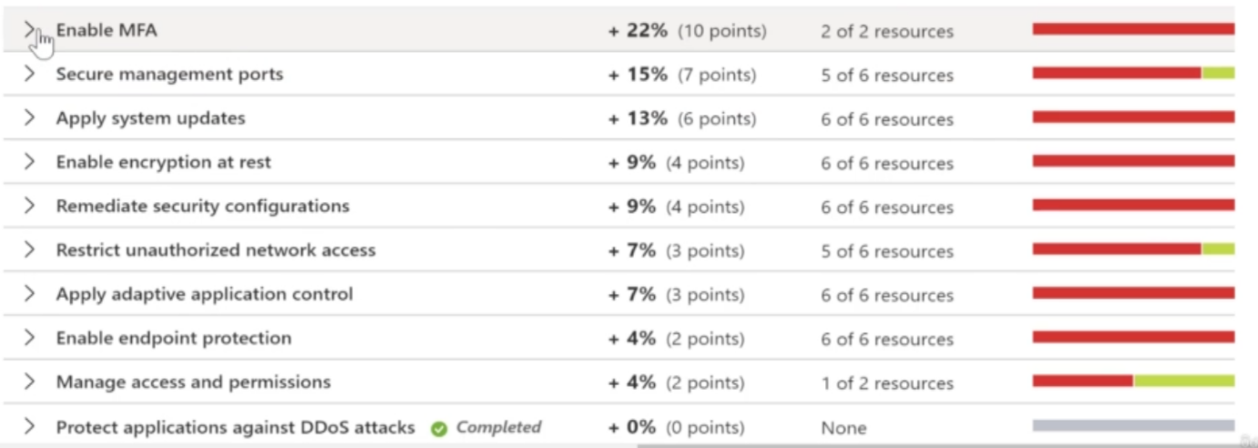

So it scans the resources and it gives you recommendations. Now, it also has the ability to scan some vulnerabilities for some of the resources and enhanced monitoring on certain resources as well.

There are two pricing tiers for Azure Security Center. If you go to Pricing and settings in Azure Security Center, and go to the desired subscription

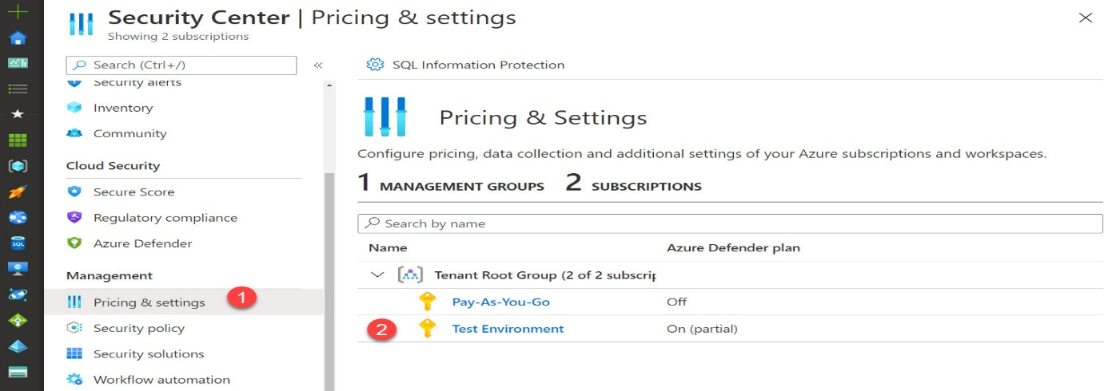

Here you can see the settings for Azure Defender. Azure Defender can protect resources based on a particular pricing model.

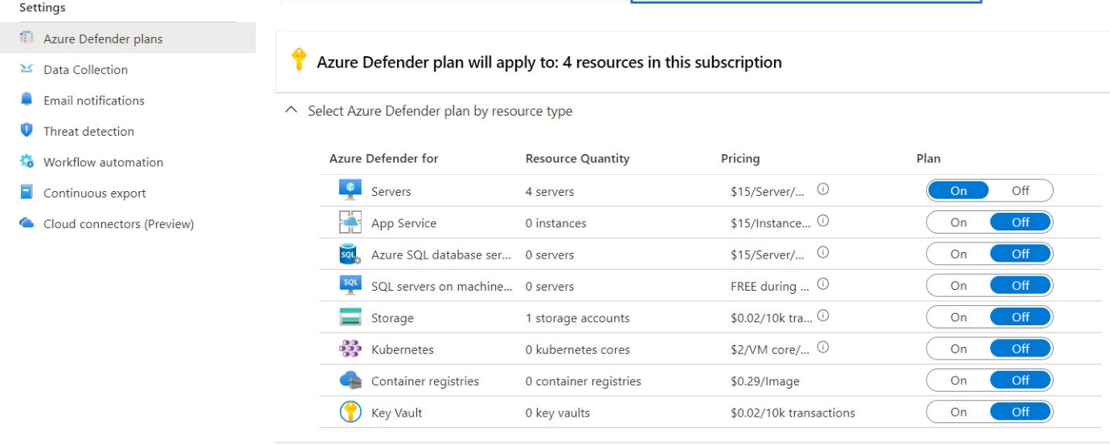

Azure Security Center can also scan you container images

1. **Multifactor Authentication:**

This is an additional layer of security when comes to authentication.

* Get the code via SMS
* Get the call on registered phone number
* Use Microsoft Authenticator App

**Step 1:** Go to your Azure AD -> Go to User -> create new user -> Then go back to AD 🡪 go to Security

There are many ways to protect your organization, out of them one is to enable MFA for users.

So click on MFA -> Go to Additional Cloud based MFA settings -> it will redirect to another link where you can actually go ahead and enable multifactor authentication on a user by user basis.

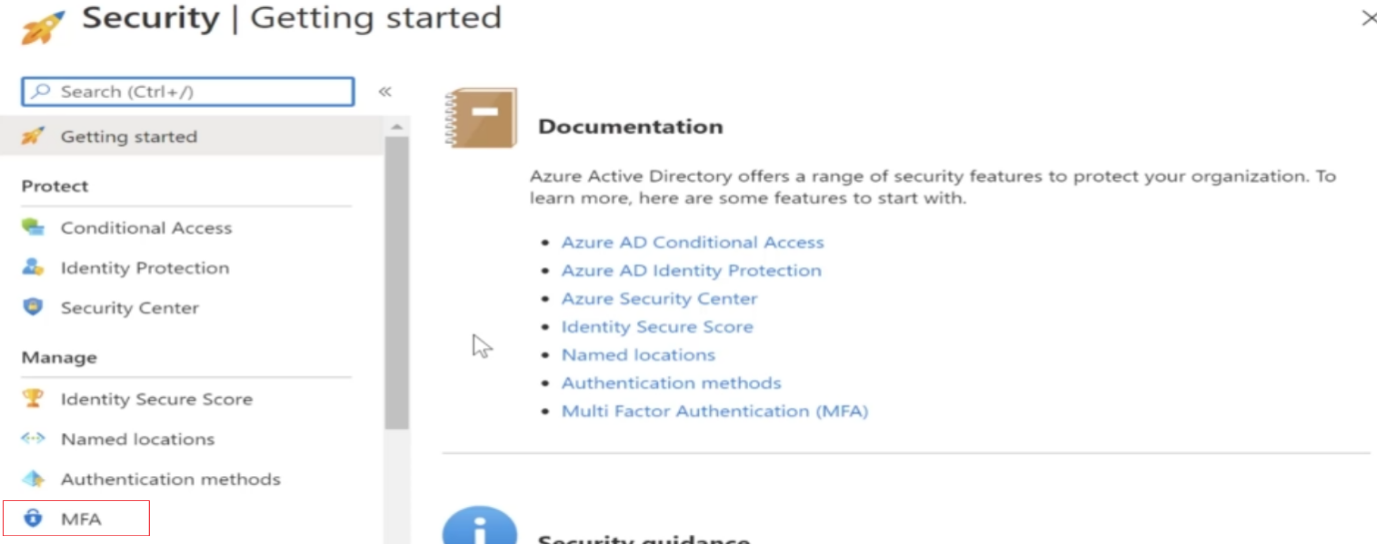

**Step 2:** Over here we have two settings. One is your server settings and then you have users. So you can go on to users.

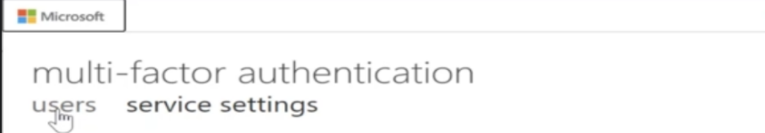

This will give you a screen with all of your users in your default directory. Now enable MFA -> For this particular user now the status has changed from disabled to enabled. So that means now this user has to go ahead and perform the step of multifactor registration, MFA registration.

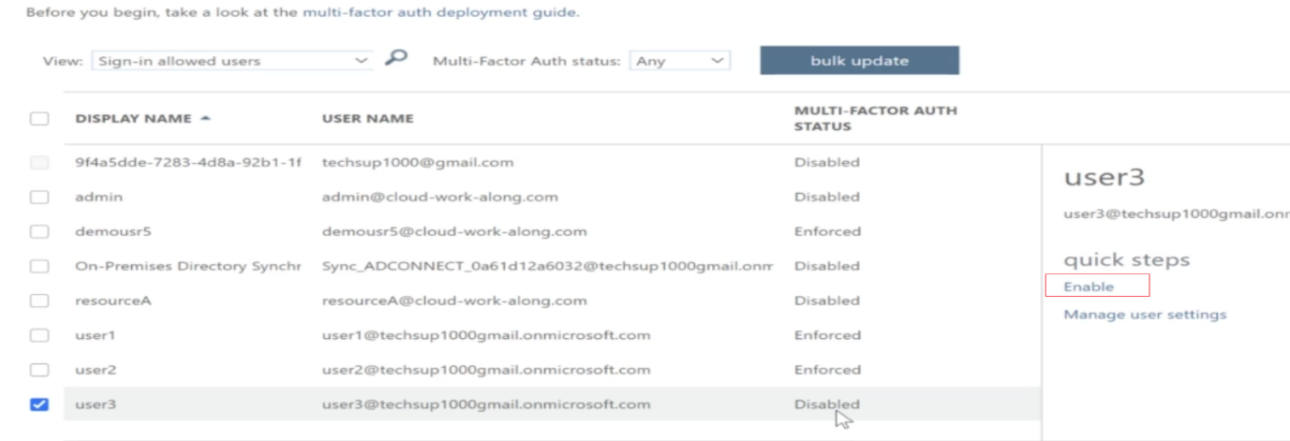

**Step 3:** Once user go for login -> it will ask for more information

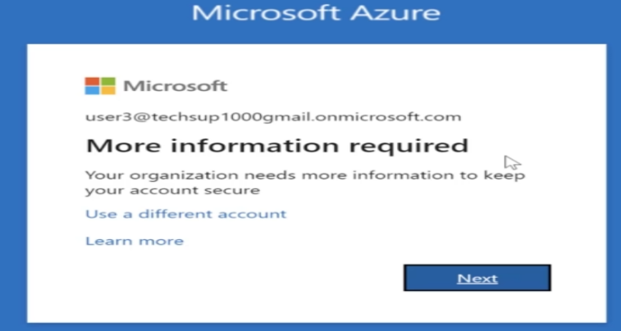

**Step 4:** Click Next -> Here it will ask how do you want to be authenticated as the next layer of security, what do you want to choose as your next layer of security for authentication, so you could go out and choose an authentication phone or you can go out and choose a mobile app.

**Step 5:** Once above done -> then state of user will set to Enforce



1. **Conditional Access Policies - Azure DevOps:**

How can we actually go ahead and implement a conditional access policies for users who are authenticating via Azul AD onto as your DevOps services?

**Step 1:** Go to Azure AD -> Security -> Conditional Access -> Create New Policy

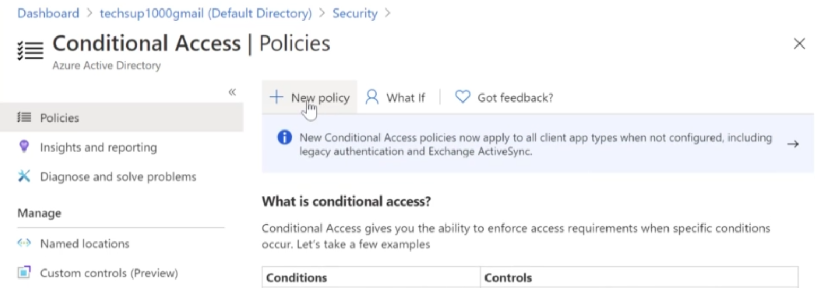

**Step 2:** Let's go ahead and create a conditional access policy that applies to all users from Azure AD, that I could connect on to as your DevOps organization.

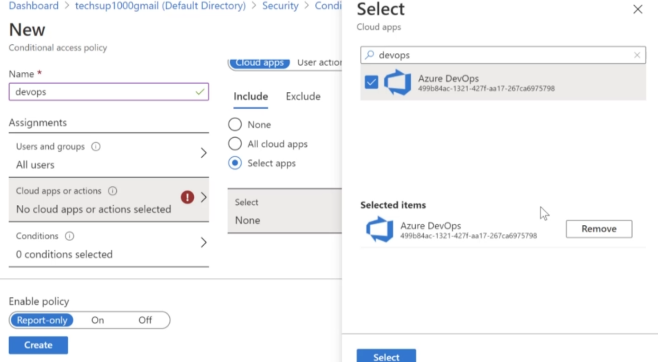

**Step 4:** In Azure DevOps -> In organization Settings -> Go into policies over here and enable this setting, only then will it work.

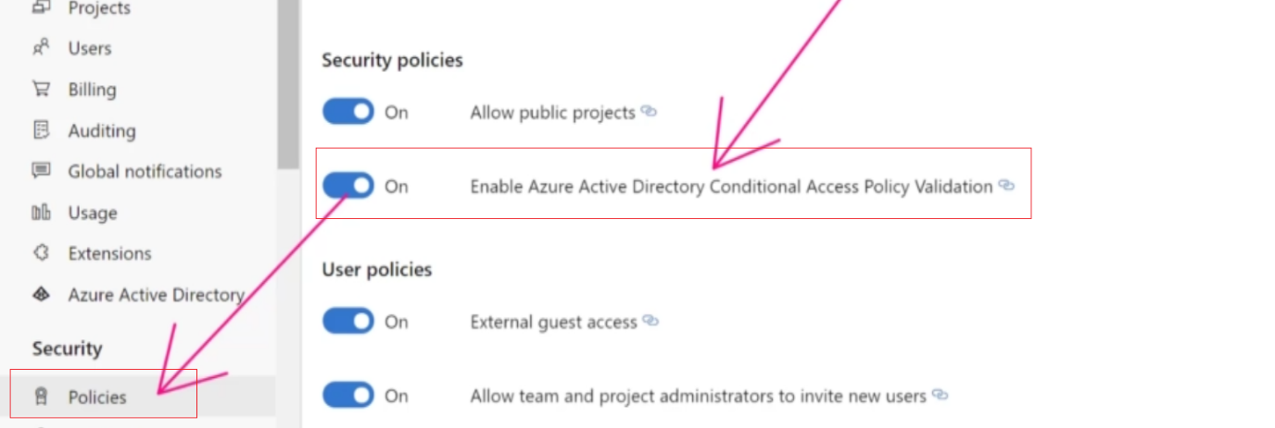

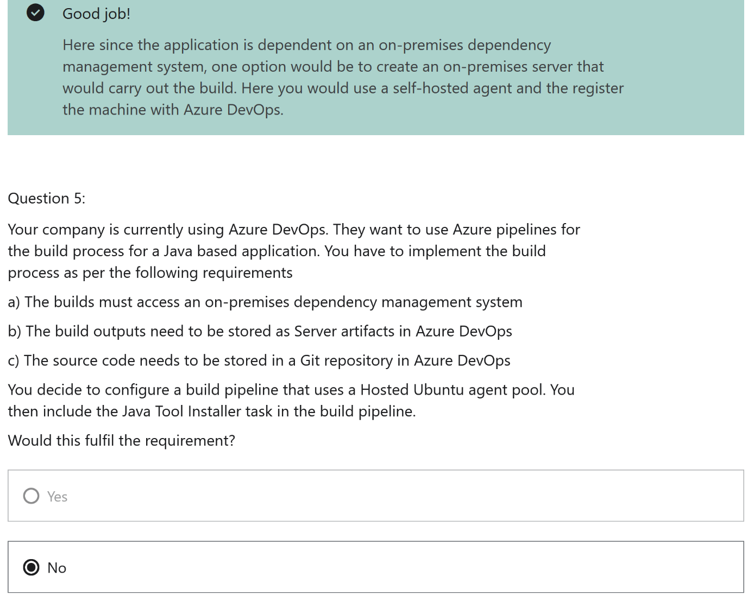

# SC-900 Azure/Microsoft 365 Security

# 

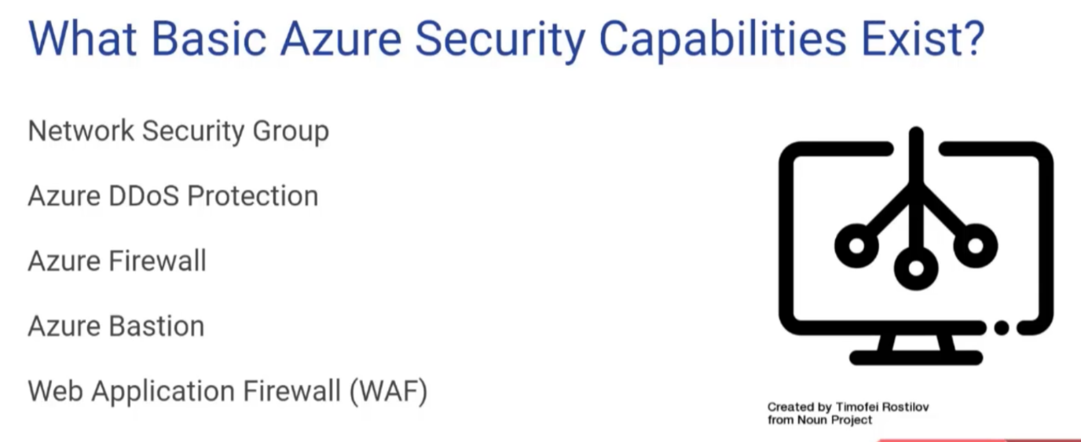

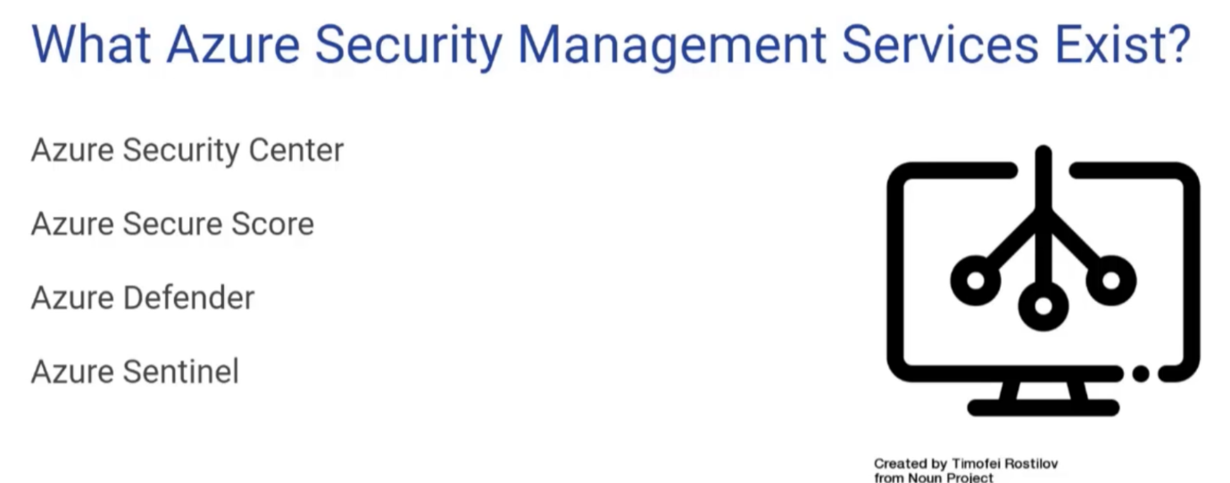

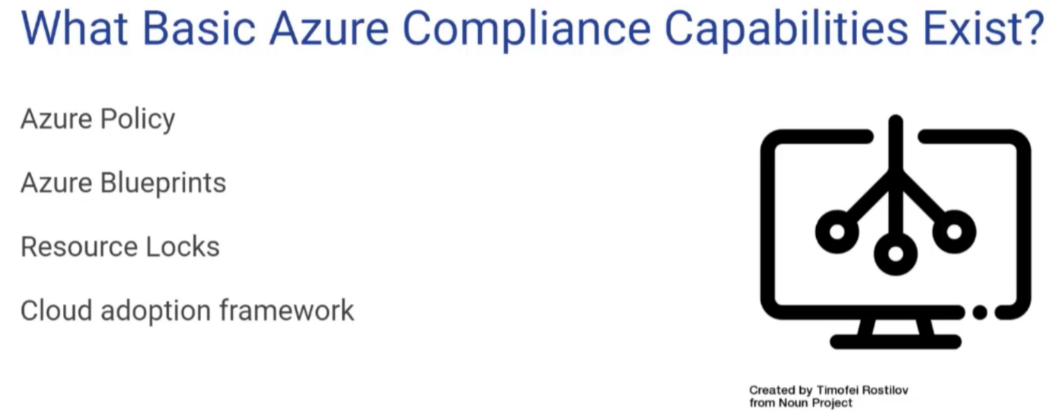

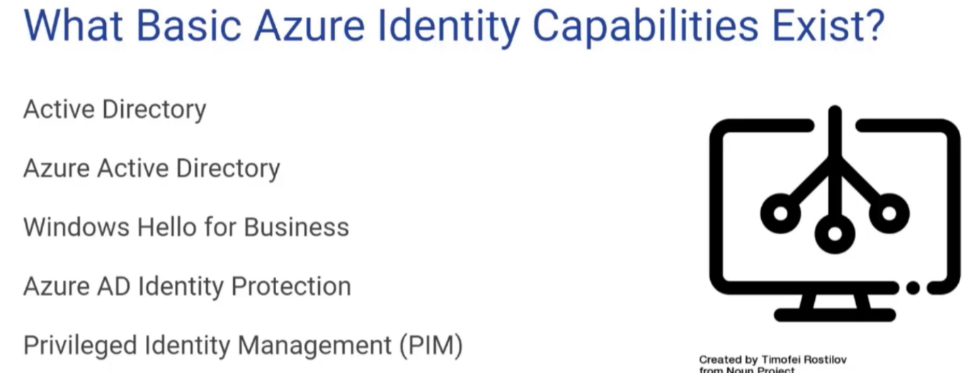

1. **Security Methodology:**
   1. **Zero-Trust Methodology:**

**It says don’t assume everything behind the firewall is safe** - Like to use the analogy of your house. Now, the chances are good that you have a strong lock on your front door, but once inside your house, most of the doors don't have locks. The drawers, the storage locations are not locked. So once somebody is inside your house, they pretty much have full access to all of the contents of your house.

You want to basically put locks on the sensitive areas of your application, behind the firewall, and you do want to make sure that only authorized people have access to what they're only allowed to do.

Three main Zero-Trust principles.

* Verify explicitly
* Use the least privileged access
* Assume Breach

We're talking about verifying the identity and we've moved beyond the simple user id and password method for identity and implemented MFA. But you can even go beyond that and making sure people can only use access your application from the office or from a geographic location.

There are two concepts related to this.

* JIT (Just in Time)
* JEA (Just Enough Access)

At database side - you can put column level protection on that for encryption. There's no end to end encryption. So from the client's right to the server with no unencrypted points in between all data within Microsoft Azure is encrypted by default. It's encrypted at rest.

At network level, which at that layer makes sure that all communications are encrypted, even internal to the network HTTPS as always, so that there's no man in the middle attacks that are able to read communications.

* 1. **Defence in Depth:**

It is much more secure to have several types of security protecting your assets than to have a single type of security.

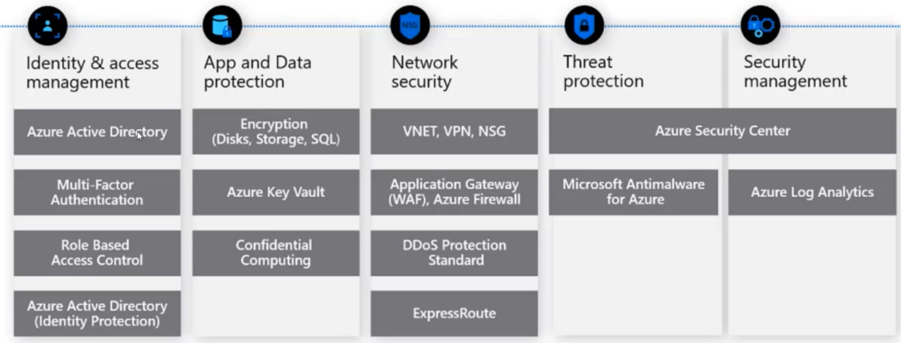

Example -> your house having a single lock on the front door and then once they're inside, they have full access to the house.

* When you're designing cloud applications, it's probably better to have several types of security so you can have identity protection. That's protecting the user IDs and passwords.
* You can have advance threat detection to make sure that any attackers get detected.
* But once they're inside, you can have all of your data encrypted.
* You can keep those keys in an Azure Key vault.
* You can even have the server running in confidential computing, which is a physical server environment that is designed specifically to protect secrets in memory.
* You could use denial of service, attack protection.
* You could have a firewall.
* You can have very tight rules on your Virtual Network, et cetera.
  1. **Common Threats:**

**Phishing Attack:** effectively an email or some type of message that will come to an individual and will trick them into clicking on the link. Chances are, you know, point the one percent of those people will get fooled into clicking on the link and will enter their credentials onto a fake Web page.

**Spear Phishing:** Specific type of phishing where they're trying to attack a single individual.

**Tech Support Scam:** Tech support scams have been around for a long time, and those are when someone will call you, email you a message or pop up on your screen saying, oh, we detected this is Microsoft, we detected a problem with your computer. And then they're going to trick you into installing some malicious program.

**SQL Injection**

**Malware, trojans, viruses**

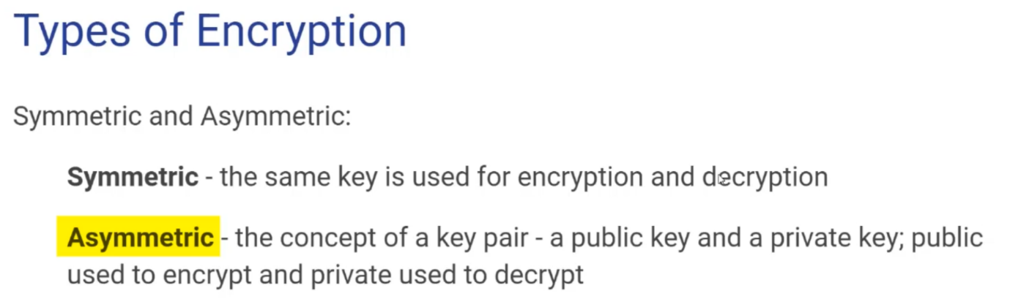

* 1. **Hybrid Identity:**

It is some mixture between on premises and the cloud. And so, hybrid identity is that are users who are authorized and authenticated by your on premises Active Directory can also use those same identities to use.

Within Microsoft Azure the tool that connects Azure to on premises and is appropriately called Azure AD connect. Azure AD is a piece of software that you can download and Install on your on-premise, that will connect to your corporate Active Directory extract the users and the hashes of their passwords and synchronize that to the cloud.

Azure AD connect actually enables Single Sign On.

* 1. **Web Application Firewall:**

Protect your application against below.

